University of Macau

Faculty of Science and Technology



Hole Detection in Wireless Sensor Networks – A Deep Learning ApproachHole Detection in Wireless Sensor Networks – A Deep Learning Approach

**by**

**NG KIM HOUNG KIM HOU, Student No: DB625369****DB625369**

Final Project Report submitted in partial fulfilment  
of the requirements of the Degree of   
Bachelor of Science in Computer Science

Project Supervisor

Prof. Yain Whar SI, Lawrence

Mr. Se-Hang Cheong, Eric

04 June 2020

DECLARATION

I sincerely declare that:

1. I and my teammates are the sole authors of this report,
2. All the information contained in this report is certain and correct to the best of my knowledge,
3. I declare that the thesis here submitted is original except for the source materials explicitly acknowledged and that this thesis or parts of this thesis have not been previously submitted for the same degree or for a different degree, and
4. I also acknowledge that I am aware of the Rules on Handling Student Academic Dishonesty and the Regulations of the Student Discipline of the University of Macau.

Signature : _________________________

Name : **NG KIM HOU**

Student No. : **DB625369**

Date : 04 June 2020

ACKNOWLEDGEMENTS

The author would like to express his utmost gratitude to UM for providing the opportunity to carry out a project as a partial fulfilment of the requirement for the degree of Bachelor of Science.

Throughout this project, the author was very fortunate to receive the guidance and encouragement from his supervisor.

ABSTRACT

In our works, we proposed hole detection algorithms in sensor network by using Object Detection with Convolutional Neural Network (CNN). We proposed a system design in hole labelling, hole region highlight and node identifier detection. Moreover, we proposed Object Detection Models for Hole Detection in Sensor Network, such as Graph Segmentation as Feature Extractor and Feature Transformation as Feature Extractor. To evaluate the proposed algorithms, we implemented a simulation environment and datasets with sparse and uniform sensor networks. We obtained the layout of sensor network for hole detection using the result of ten force-directed algorithms. We evaluated the performance of proposed hole detection using Sensitivity and Specificity. Experimental results showed that the proposed algorithms can detect holes correctly with an acceptable execution time.

TABLE OF CONTENTS

TABLE OF CONTENTS 5

LIST OF FIGURES 6

LIST OF TABLES 8

CHAPTER 1. INTRODUCTION 9

1.1. Contributions 10

CHAPTER 2. RELATED WORK 11

CHAPTER 3. OVERVIEW OF APPROACHES 13

3.1 Force-Directed Algorithms 14

3.2 Convolutional Neural Network (CNN) 15

CHAPTER 4. SYSTEM DESIGN OF HOLE DETECTION IN SENSOR NETWORK BY OBJECT DETECTION WITH CONVOLUTIONAL NEURAL NETWORK (CNN) 16

4.1 Evaluation of Pre-Trained Models 16

4.1.1 Evaluation of Hole Detection in Sensor Network by Irregular Shapes 18

4.2 Feature Extraction Methods 22

4.2.1 Graph Segmentation 22

4.2.2 Feature Transformation 26

4.2.3 Specific Classification 29

4.3 Datasets Preparation and Model Training 32

4.4 Application from Sensor Networks 35

CHAPTER 5. EXPERIMENTS 37

5.1 Dataset Preparation 37

5.2 Experiment Settings 39

5.3 Performance Evaluation of Hole Detection in Sensor Network by Convolutional Neural Network 41

5.4 Visualization of Hole Detection in Sensor Network by Convolutional Neural Network 49

CHAPTER 6. ETHICS AND PROFESSIONAL CONDUCT 53

CHAPTER 7. CONCLUSION 54

CHAPTER 8. REFERENCE 56

LIST OF FIGURES

Figure 1 An example of holes in a sensor network. 12

Figure 2 An output text file of the layout after force-directed algorithm (a), (b) image after visualizing the text file 13

Figure 3 The workflow of hole detection in the layout of sensor network. 15

Figure 4 The weight file and configuration file of YOLOv3. 18

Figure 5 Default and modified configuration of YOLOv3 for Irregular Shape Detection Model. 19

Figure 6 Average loss of the Irregular Shape Detection Model. 20

Figure 7 The Workflow of generating hole object for model training 21

Figure 8 An example of hole segmentation from a sensor network. 22

Figure 9 The sparse sensor network used in the performance evaluation of Graph Segmentation. 22

Figure 10 The screenshot of dataset prepared for the model training. 23

Figure 11 Average loss of the Graph Segmentation Model. 24

Figure 12 The sample output of holes detected by Graph Segmentation. 24

Figure 13 The comparison of images generated by Graph Segmentation and Feature Transformation. 25

Figure 14 Holes with different background color. 26

Figure 15 Average loss of the Feature Transformation Model. 26

Figure 16 The sample output of holes detected by Feature Transformation. 27

Figure 17 Samples that cannot be detected as holes by Graph Segmentation model. 27

Figure 18 The sample of prediction Graph Segmentation by using Feature Transformation model. 28

Figure 19 The four types of categories in hole object. 28

Figure 20 The labeled Feature Transformation by Specific Classification. 29

Figure 21 Average loss of the Feature Transformation with Specific Classification Model. 30

Figure 22 The sample output of holes detected by Specific Classification model. 31

Figure 23 The sample Graph Segmentation holes detected by Feature Transformation with Specific Classification. 31

Figure 24 Three types of features in Training Dataset. 32

Figure 25 The general workflow of model training for proposed models. 32

Figure 26 Average loss of the Hole Detection Model in Sensor Networks at iteration 1 to 6000 (a) and 33

Figure 27 An example of instant segmentation of a sensor network. 35

Figure 28 An example of instance segmentation mask from a sensor network. 35

Figure 29 Example of (a) sparse sensor network, (b) uniform sensor network. 36

Figure 30 An example of result of hole detection of (a) ground truth dataset, (b) layout of force-directed algorithm. 39

Figure 31 An example of layout with high number of nodes and average degree. 40

Figure 32 Workflow of performance evaluation of hole detection in sensor network with Convolutional Neural Network (CNN). 42

Figure 33 Sensitivity of hole detection of force-directed algorithms and (a) number of nodes and (b) average degree in sparse sensor network. 43

Figure 34 Specificity of hole detection of force-directed algorithms and (a) number of nodes and (b) average degree in sparse sensor network. 44

Figure 35 Sensitivity of hole detection of force-directed algorithms and (a) number of nodes and (b) average degree in uniform sensor network. 46

Figure 36 Specificity of hole detection of force-directed algorithms and (a) number of nodes and (b) average degree in uniform sensor network. 47

Figure 37 The Sparse Sensor Networks with 500 nodes and 8 average degrees detected by Hole Detection Model. 48

Figure 38 The Uniform Sensor Networks with 1000 nodes and 6 average degrees detected by Hole Detection Model. 49

Figure 39 The Uniform Sensor Networks with 2000 nodes and 6 average degrees detected by Hole Detection Model. 50

Figure 40 The Sparse Sensor Networks with 3000 nodes and 15 average degrees detected by Hole Detection Model. 51

LIST OF TABLES

Table 1 Pre-trained models and dataset. 16

Table 2 Result of object detected by pre-trained models. 16

Table 3 Original images and label of holes in original images. 17

Table 4 Average IoU and mAP of the Irregular Shape Detection Model. 19

Table 5 Hole labeling and result of hole detection of YOLOv3. 20

Table 6 Average IoU and mAP of the Graph Segmentation Model. 24

Table 7 Average IoU and mAP of the Feature Transformation Model. 27

Table 8 Average IoU and mAP of the Feature Transformation with Specific Classification Model 30

Table 9 Average IoU and mAP of the Hole Detection Model in Sensor Networks 34

Table 10 The sparse sensor networks used to train hole detection model. 37

Table 11 The uniform sensor networks used to train hole detection model. 38

Table 12 Attributes and notations used in the experiments. 38

Table 13 Performance evaluation criteria of Node Identifier Matching. 40

# INTRODUCTION

Complex non-convex sensor networks (CNCAH) contain intersecting polygons and edges. In many instances, the layouts of these networks are not entirely convex in shape. This kind of network is suitable to be the image data that can represent the real situation of the deployment of sensor network. In our application, we interests sensors in which their connection range is homogeneous.

Force-directed algorithms [1] have been developed over the last 50 years and used in many application fields, including information visualisation, biological network visualisation, sensor networks, routing algorithms, scheduling, and graph drawing. This is a force-oriented algorithm, which means that the top layout is determined by the force that pulls the tops together into their push away. Attraction only occurs between adjacent tips, and the displacement of the tip between each pair of tips can be mitigated by this alternating system temperature: the transformation algorithm is performed in successive iterations, and the temperature should be lowered so that users provides cooling schedule, attractiveness and offset force. For example, in general, the force-oriented approach defines an objective function that maps each graphical layout to a number in R+, representing the energy of the layout. This function is defined in such a way that low energy corresponds to the layout that the distance between adjacent nodes is close to a pre-specified distance, and the distance between adjacent nodes is good. Then calculate the layout of the graph by finding the minimum value of this objective function.

Hole Detection of Sensor Network is a very useful technology today, even in future. Wireless sensor networks are widely used, from company to school, hospital to home, and military applications to environmental monitoring. In many security-relevant scenarios, such as earthmoving and mining cases, we need to determine if there are topological holes in the spatial topology, so we can send emergency alerts to users to prevent sudden disasters and there is enough disaster. Handle accidents in a timely manner. Node organizing and management is a harsh work, it is important that making sure all areas are covered. A hole in sensor network means exist an area that cannot be sensing or transmitting data, because holes can cause interruptions in sensing or transmitting tasks, detecting holes in coverage areas is a necessary task. In this paper, it will introduce classical methods and machine learning methods.

About classical hole detection algorithm, divided into two types, geometrical methods, statistical methods. In this project, statistical method is not our research target, mainly discusses geometrical and topological methods. About geometrical methods, most use image processing, which is a simple and intuitive method. There are nodes and edges in a sensor network, with coordinates. These are all the input of the algorithm, actually these elements is a complete sensor network graph. Doing image processing in the network graph, satisfactory results and high accuracy. Therefore, geometrical methods is a preferred choice in classical hole detection algorithm. About topological methods, the method of identifying hole is particularly challenging because a typical wireless sensor network consists of lightweight, low-capacity nodes that do not know its geographic location. Therefore, topological methods would be non-primary hole detection methods.

Evaluation of Neural Networks for Hole Detection, we would use neural network for evaluating the performance of existing models for hole detection. We may not train a new model at the beginning that we just use the existing models from different research fields. Experimental settings need to be set, experimental and analysis may take long time, and the important is it is possible that no any model is suitable for us. Therefore, train a new model is a feasible solution, but only if there is a lot of training data.

## Contributions

1. Propose an approach based on Convolutional Neural Network (CNN) and force-directed algorithms for the hole detection in sensor network
2. Select pre-training models of Convolutional Neural Network, and evaluate their performance for the hole detection in sensor network
3. Propose two approaches for collecting the feature of holes in sensor networks. They are Graph Segmentation and Feature Transformation.
4. Propose four types of categories for the feature classification of hole object. They are hole with 4 boundary nodes, hole with 5 boundary nodes, hole with 6 boundary nodes, and hole with simple polygon.
5. Design and train models of Convolutional Neural Network (CNN) for the hole detection in sensor networks
6. Design and implement the Instance Segmentation algorithm for boundary detection of holes
7. Design and implement the algorithm for node identifiers recognition on the boundary of holes
8. Evaluate the performance of the proposed Convolutional Neural Network models for hole detection in sensor networks.

# RELATED WORK

Hole and boundary detection method can be divided into three methods geometrical methods, statistical methods and topological methods.

Sahoo, et al. [2] proposed SBNS and DBNS algorithms for sequential and distributed boundary node selection. The SBNS algorithm assumes that the receiver is a boundary node, and then uses a right-hand rule to select the boundary nodes in a sequential manner. The BNS algorithm defines limit nodes as boundary nodes, and then connects them to form a loop that surrounds the boundary. An extreme node is defined as a node that has a maximum or minimum value in its coordinates compared to a one-hop neighbour.

Destino and de Abreu [3] proposed a graph theory-based centralized boundary recognition algorithm (BRGT) based on graph clustering technology, which can divide the network into small units that avoid connection holes. Then, the concentration nodes are used to identify the boundary nodes of each cluster. The detection of boundary nodes is performed by the fusion of adjacent clusters. Only nodes that are on a single cluster boundary and not connected to two or more clusters are selected as boundary nodes. The algorithm is centralized, and the base station must collect the entire network topology to begin the discovery process, which is not suitable for large sensor networks.

Funke [4] introduced a topological hole detection (THD) algorithm based on the contour idea. After four beacons are selected, nodes with the same number of hops from the beacons should belong to the same contour. These contours are divided into connected components due to the presence of holes or when encountering outer boundaries. For each connected component, a local beacon is selected and the calculation of the shortest distance to that beacon is performed. The node with the highest distance value must be on both “ends” of each connected component. These nodes are marked as boundary nodes. The algorithm is implemented in a distributed manner in by selecting the largest set of independent nodes in the network. Then a contour line is constructed for the six-hop neighbourhood around each seed node.

Hsieh and Sheu [5], a four-stage distributed boundary recognition algorithm (DBRA) is described. The first stage is to select a closed node (CN) that roughly surrounds the holes and boundaries of the induction field. It should be noted that for simplicity, the authors use the term obstacles instead of holes and boundaries of the induction field. In the second phase, these closed nodes are connected to each other to form a coarse boundary cycle (CBC) for identifying each obstacle. A third stage is proposed to discover the exact boundary nodes (BN) and connect them to refine the CBC to the final boundary. A final stage is proposed to maintain the integrity of the BN when the boundary is interrupted due to a node failure.

Wang, et al. [6], by flooding the entire network from the seed node, a shortest path tree is constructed. The algorithm then searches for nodes that are defined as the nodes’ least common ancestors (LCA) that are relatively far away and their paths to the LCA are separated. By using the cut out nodes, the algorithm artificially merges the holes into one hole to construct a compound cycle R, then synchronizes the nodes of R and floods the entire network to find the outer boundary. This algorithm has been criticized for flooding the entire network and the synchronization of periodic R nodes, which requires more execution time and communication overhead.

Dabba and Beghdad [7] proposed the BCP based on three phases: the first phase is to detect nodes close to the boundary and treat them as boundary nodes. The second phase is dedicated to finding transmissions and internal nodes. The final stage focuses on replacing the border nodes with transit nodes in the event of any failure. In this algorithm, local Voronoï polygons (LVP) are used to detect boundary nodes. The algorithm assumes that each sensor node has four edges. If the node receives at least one message from each of the four edges, its LVP is limited, so the node will decide to be an internal node. In another case, the LVP is infinite and the node sets itself as a boundary node. The main inconvenience of this algorithm is the perception of the four sides of each node.

Khan, et al. [8] introduced a self-detection algorithm (SDBR) for boundary recognition. Each node can decide whether it is a boundary or an internal boundary by constructing its 2-hop neighbor graph. The node will then check if this graph forms a closed loop or open path. A broken path indicates that the node is on a boundary, and in the case of a closed loop, the node is marked as an internal node. The main disadvantage of this algorithm is that it selects rough boundaries, in which several internal nodes are incorrectly identified as boundary nodes.

# OVERVIEW OF APPROACHES

In this chapter, we described the definition and corresponding constraints of hole in sensor networks. We defined that a hole in sensor network is an irregular shape composed of nodes and edges. We focus on inner holes in sensor network. Therefore, outer (outward) holes in sensor (highlighted in yellow) are not considered in our application. In addition, holes in a sensor network must satisfy the following constraints:

* No node was allowed inside the hole.
* A hole must be a closed and contoured area.
* The area of hole (area of contoured) must larger than $1.25×number of nodes ×4$ pixels.
* Triangular areas do not consider as holes in sensor networks. In our application, we interest sensors in which their connection range is homogeneous. If nodes are connected directly (e.g., connected in 1-hop) this implies that the distance among them are closed. Therefore, we do not consider the contoured area among these nodes as holes.

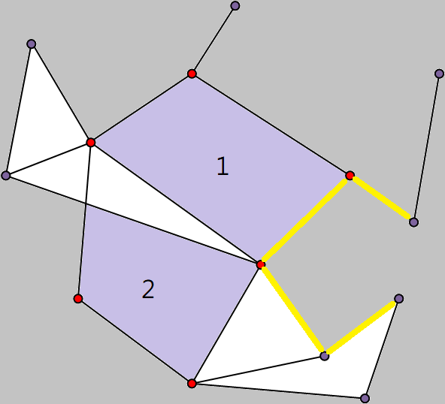

***Figure 1 An example of holes in a sensor network.***

An example of holes in a sensor network is illustrated in Figure 1 which consists of 14 nodes and 21 edges. Contoured area with purple specifies the region of holes. Red nodes specify the nodes located on a hole. In addition, the sensor network has two holes and labelled as 1 and 2 respectively.

## Force-Directed Algorithms

The force-directed layout algorithms are graphics drawing algorithms based only on the information contained in the structure of the graphic itself rather than relying on context information. The simplest force-oriented algorithm uses repulsive forces between nodes and attractive forces between adjacent nodes. The physical model produces some local minima in which the graph becomes stable and is drawn in an aesthetic manner. Also known as spring embedders, such algorithms calculate the layout of a graph using only information contained within the structure of the graph itself, rather than relying on domain-speciﬁc knowledge. The main algorithm consists of a main loop, which performs some iterative simulations on the system and then draws the graph. The system will include repulsive forces between all graph nodes and attractive forces between adjacent nodes.

The input of the force-directed algorithm is the ground truth sensor network. We used 10 force-directed algorithms as the input of the approach of Contour Tracing Algorithm (CTA), they are Fruchterman Reingold (FR) algorithm [9], Kamada Kawai (KK) algorithm [10], Davidson Harel (DH) algorithm [11], ForceAtlas2 (FA2) algorithm [12], force-directed edge bundling (FDGE) algorithm [13], Fruchterman Reingold with range extension (FRR) algorithm [14], CWBound algorithm [15], JIGGLE algorithm [16], LinLog algorithm [17] and Kamada Kawai with multiple node selection and decaying stiffness (KK-MS-DS) algorithm [18].

The output of the layout after force-directed algorithm in Figure 2 (a) is a text file that include nodes coordinate and connection. This file becomes the input of the approach of Contour Tracing Algorithm (CTA) for hole detection in sensor networks. Pass the output file to parser, after automatic scale node coordinates and calculating suitable canvas, the result is Figure 2 (b), then it satisfies the requirements for hole detection by Contour Tracing Algorithm (CTA).

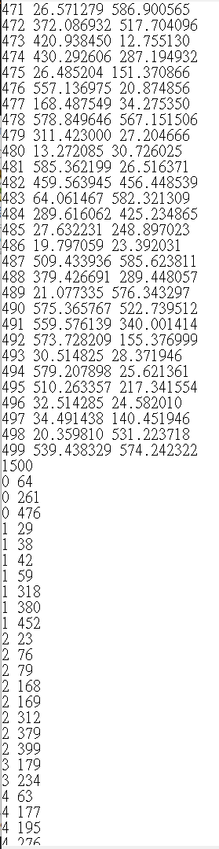 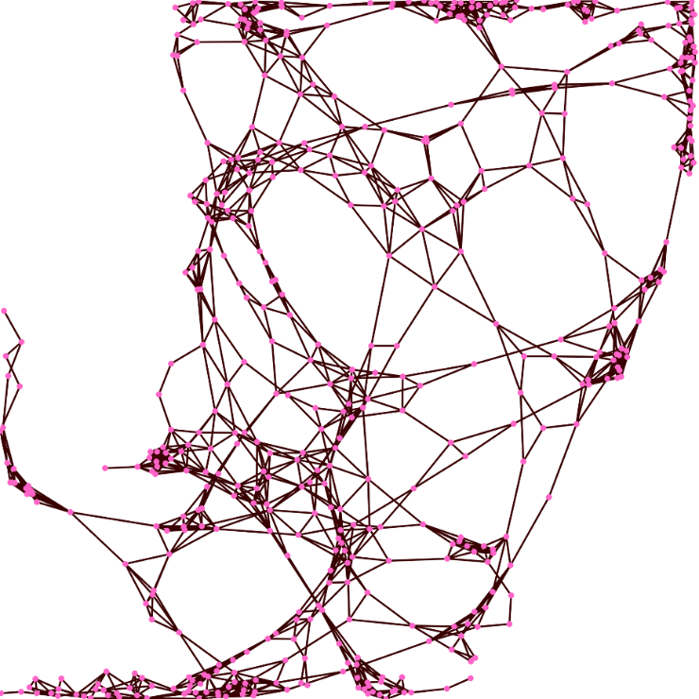

(a) (b)

***Figure 2 An output text file of the layout after force-directed algorithm (a), (b) image after visualizing the text file***

## Convolutional Neural Network (CNN)

Neural network is the challenge method to evaluate the hole detection. We evaluate the performance of existing models of neural networks for hole detection. Firstly, we do not need to train a new model at the beginning, we try to use the existing models from different research fields, such as Object Detection, Edge Detection, Semantic Segmentation, etc. Therefore, we just picked a detection model which produce an acceptable accuracy in hole detection.

Convolutional Neural Network (CNN) is a Deep Learning approach, it was developed in the 1980s, and it has been applied to image, text and speech. the Noncognition [19] was a predecessor to Convolutional Neural Network (CNN). Convolutional Neural Network (CNN) simulates human visual system. Humans can correctly identify cats and dogs because of humans recognized the feature of object. A typical Convolutional Neural Network composed of convolutional layer and dense layer. The purpose of the first convolutional layer is to extract the general pattern found in the local area of the input image. The convolutional neural network used the learned filtering to convolution on the input image, calculates the inner product of each image position in the image, and outputs the result as a tensor, whose depth is the number of filters. This is the approach of feature extraction by Convolutional Neural Network. Therefore, suppose Convolutional Neural Network is able to extract the feature of hole object and detect the hole object in sensor networks, it might implement the hole detection in sensor networks by Object Detection with Convolutional Neural Network.

YOLOv3 [20] is an Object Detection system by using Convolutional Neural Network. YOLO was proposed by Joseph Redmon [9]. The system passes the n by n image only once in a fully convolutional neural network (FCNN). YOLOv3 [20] is has a higher accuracy with logistic regression and threshold, than YOLOv3 no need to use high configuration computer. Finally, we selected YOLO to implement the hole detection in sensor networks by Convolutional Neural Network (CNN).

# SYSTEM DESIGN OF HOLE DETECTION IN SENSOR NETWORK BY OBJECT DETECTION WITH CONVOLUTIONAL NEURAL NETWORK (CNN)

We described the workflow and proposed models for the hole detection in sensor network in this chapter. In Chapter 4.1, we introduced hole detection using pre-trained models. The approaches for collecting the feature of holes and the classification are described in Chapter 4.2. In Chapter 4.3, we described the boundary identification approaches used in the with convolutional neural network. The workflow of hole detection in the layout of sensor network is illustrated in Figure 3.

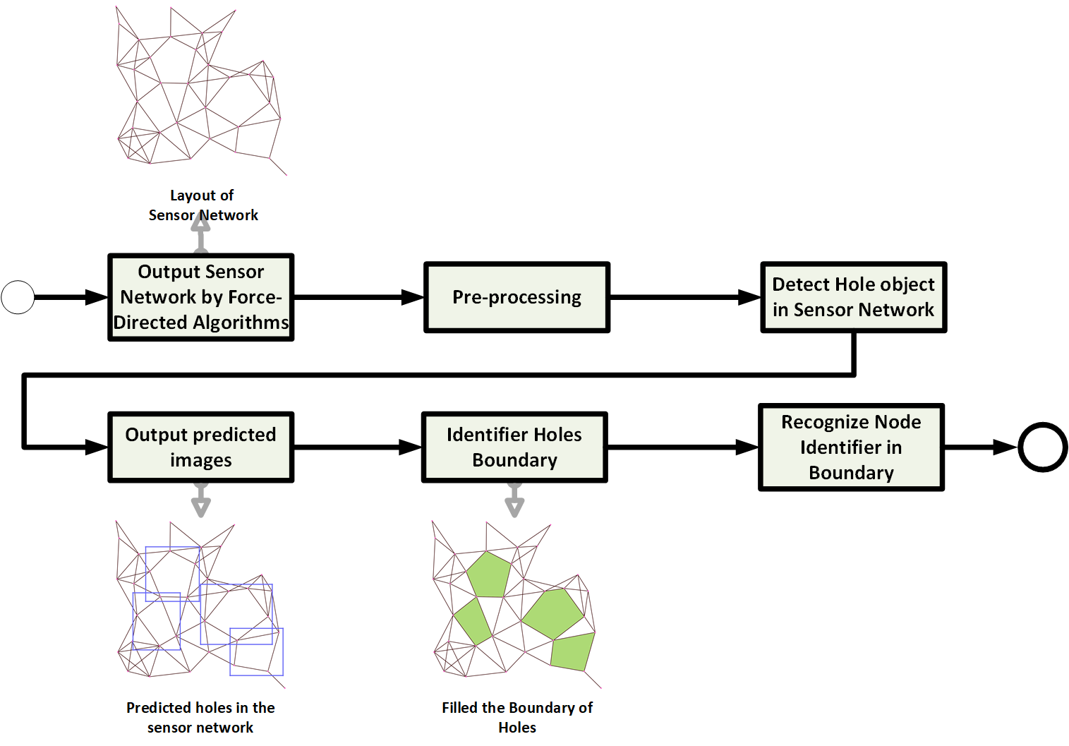

***Figure 3 The workflow of hole detection in the layout of sensor network.***

## Evaluation of Pre-Trained Models

At the time when we investigate to use Convolutional Neural Network (CNN) for the hole detection in sensor network, we got few interesting questions to clarify. For example, what feature the hole may look like? Is it possible that the features of hole have been conducted by pre-trained models? In addition, would the feature of hole similar to existing classes of objects? For instant, spider webs look similar to the topology of network. Does it mean that they have a change to share common features? The objective for this evaluation is to detect objects in sensor network by applying pre-trained models. Precisely, we are interested in finding objects similar to the hole that using pre-trained models with their corresponding dataset.

We collected and evaluated pre-trained models in YOLO for the hole detection in sensor networks to clarify above questions. Also, we trained a YOLO model for experiment YOLO detection in new object.

In evaluation of pre-trained models, we selected a lots of pre-trained models for have been provided by the YOLO developer community [21, 22]. We selected few latest pre-trained YOLO models in our experiments that are based on state-of-art models, such as CSP [23], PRN [24], EfficientNet [25], etc. Pre-trained models and their corresponding dataset evaluated in our experiments are summarized in Table 1. We performed evaluation in the Microsoft Windows 10 operating system. An example of command to apply a pre-trained model *YOLOv3* for detecting holes in the layout of sensor network *n=500d=6* is shown as follows:

darknet_no_gpu.exe detect cfg/yolov3.cfg yolov3.weights dataset/Uniform/n=500d=6.bmp

***Table 1 Pre-trained models and dataset.***

|  |  |
| --- | --- |
| **Pre-trained YOLO Model** | **Training Dataset** |
| YOLOv3 | COCO [26] |
| YOLOv3 SPP |
| YOLOv3 EfficientNetB0 |
| YOLOv3 CSP |
| YOLOv3-tiny PRN |
| YOLOv3 OpenImages | OpenImages [27] |
| YOLOv2 9000 | Yolo9000 [28] |

In addition, we evaluated 7 pre-trained models as summarized in Table 1. In the experiment, we applied each pre-trained model to detect objects in both ground truth dataset ($D_{U}$) and ($D_{S}$). That mean, each model evaluated 20 uniform and 20 sparse sensor networks in terms of variant number of nodes and average degree.

The number of objects detected by pre-trained models is summarized in ***Table 2***. According to the experimental result, Models ***YOLOv3 SPP*** and ***YOLOv3 OpenImages*** achieved the largest number of objects detected in ground truth dataset ($D_{U}$) and ($D_{S}$). Model ***YOLOv2 9000*** detects nothing from both datasets.

***Table 2 Result of object detected by pre-trained models.***

|  |  |
| --- | --- |
| **Pre-trained YOLO Model** | **Number of objects detected in ground truth datasets** |
| YOLOv3 | 19 |
| YOLOv3 SPP | 27 |
| YOLOv3 EfficientNetB0 | 10 |
| YOLOv3 CSP | 18 |
| YOLOv3-tiny PRN | 1 |
| YOLOv3 OpenImages | 27 |
| YOLOv2 9000 | 0 |

Moreover, we presented a visualization of the class of object detected in ground truth dataset ($D_{U}$) and ($D_{S}$). According to the prediction results of these models, the umbrella is most similar to our sensor network. The second is the bird and building.

### Evaluation of Hole Detection in Sensor Network by Irregular Shapes

Our first attempt is to evaluate the capability of YOLO in detecting holes in sensor networks according to the definition defined in CHAPTER 3. The objective of our attempt is to observe whether the YOLO is able to detect holes if very little amount of features are provided. That mean, we prepared datasets of hole with simple (no noise) and minimum account of feature. According to our assumption, we expect the result of hole detection with our datasets prepared should be in an acceptable accuracy because there is no noise and the feature of our dataset is constructed in a simple manner. Moreover, the following description details the procedure to prepare our datasets, summarized and concluded the result of this experiment.

In evaluation of irregular shape detection model, we prepared datasets by labeling holes in different features, such as high/low contrast ratio of foreground and background color, size of the holes, rounded or shaped corner of holes, rotation angle of holes, etc. Original images and holes labeled to train the Irregular Shape Detection Model are summarized in Table 3. We used gray color to highlight the label holes from original images where illustrated in the second, fourth and sixth columns.

***Table 3 Original images and label of holes in original images.***

|  |  |  |  |  |  |
| --- | --- | --- | --- | --- | --- |
| **Original image** | **Label of hole in original image** | **Original image** | **Label of hole in original image** | **Original image** | **Label of hole in original image** |
|  |  |  |  |  |  |
|  |  |  |  |  |  |
|  |  |  |  |  |  |
|  |  |  |  |  |  |
|  |  |  |  |  |  |

Labeled holes are marked manually by a toolkit LabelImg [29] in which the feature of holes are learned by YOLO during its training process. A weight file is then produced by YOLO after training processing that presents the features of holes have been learned based on the labeled holes. The screenshot of weight file and configuration file is illustrated in Figure 4.

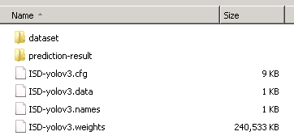

***Figure 4 The weight file and configuration file of YOLOv3.***

In this experiment, we trained the feature of Irregular Shape Detection Model based on the configuration of YOLOv3. In fact, YOLO has two fundamental configurations available; they are YOLOv3[1] and YOLOv3-Tiny[2]. The configuration of YOLOv3 and YOLOv3-Tiny contains 75 and 13 convolutional layers respectively in which YOLOv3-Tiny is in fact based on YOLOv3. Specifically, 62 convolutional layers from YOLOv3 are eliminated for YOLOv3-Tiny in order to reduce the time to train a model. Therefore, YOLOv3-Tiny is faster than YOLOv3 in training a model but has low accuracy in prediction.

We decided to use the configuration of YOLOv3 in the evaluation of Irregular Shape Detection Model because accurately detected a hole in the sensor network is useful than the speed of training. Moreover, we modified batch settings in which 24 images are allowed to be processed in one batch, and 8 mini batches in each batch because of the performance limitation in our hardware. The datasets used in the evaluation of Irregular Shape Detection Model are 320 × 320 bitmaps thus the width and height in the ***[net]*** section of YOLOv3 configuration is set to 320. Moreover, the parameter of maximum batches (***max_batches***) should be configured in such a way that is proportional to the number of classes of objects. We set ***max_batches*** to 10000 because we defined single class of hole in this experiment. In addition, we also configured the learning rate using the ***scales*** parameter in YOLOv3 configuration at 5000th and 8000th attempting to obtain a strong learning rate. The default and modified configuration of YOLOv3 is illustrated in Figure 5.

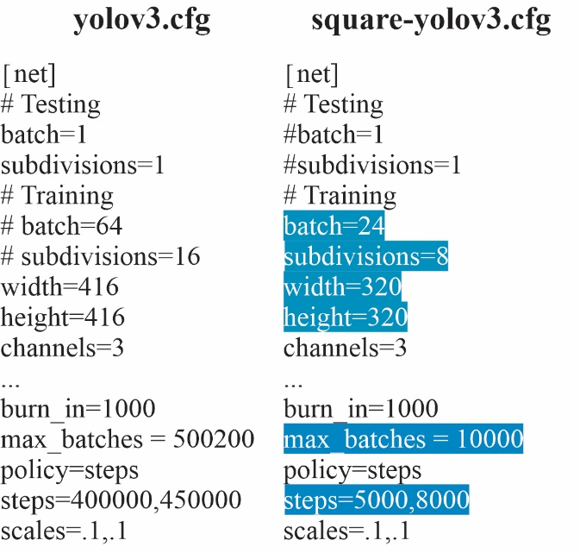

***Figure 5 Default and modified configuration of YOLOv3 for Irregular Shape Detection Model.***

In our experiment, the training of model of YOLOv3 terminated at the 10000th iteration. The average loss of the Irregular Shape Detection Model is illustrated in Figure 6. The x-axis presents the number of iterations from 0 to 10000; the y-axis presents the ratio of average loss. Furthermore, the detailed average of intersection over union (IoU) and mean average precision (mAP) are summarized in Table 4.

***Table 4 Average IoU and mAP of the Irregular Shape Detection Model.***

|  |  |  |
| --- | --- | --- |
| **Iteration** | **Average**  **Intersection Over Union**  **(IoU)** | **Mean Average Precision (mAP) @0.50** |
| 1000 | 84.01 | 0.944444 |
| 2000 | 90.98 | 0.944444 |
| 3000 | 93.04 | 0.944444 |
| 4000 | 89.72 | 0.944444 |
| 5000 | 94.65 | 0.944444 |
| 6000 | 95.34 | 0.944444 |
| 7000 | 95.16 | 0.944444 |
| 8000 | 95.15 | 0.944444 |
| 9000 | 95.38 | 0.944444 |
| 10000 | 95.51 | 0.944444 |

According to the experimental result shown in Table 4, intersection over union (IoU) and mean average precision (mAP) both exceed 94% since 5000 iterations. Intersection over union (IoU) is 95.51 and average precision (mAP) is 0.94 at the time when the training process terminated at the 1000th iteration. Therefore, experiment result showed YOLO is able to detect holes with high accuracy (without noise) that provide sufficient confident in our project to use YOLO for hole detection is applicable. It can tell us in the next step of model training, we should define proper feature of holes (with noise and complex shapes) in order to detecting holes in sensor networks.

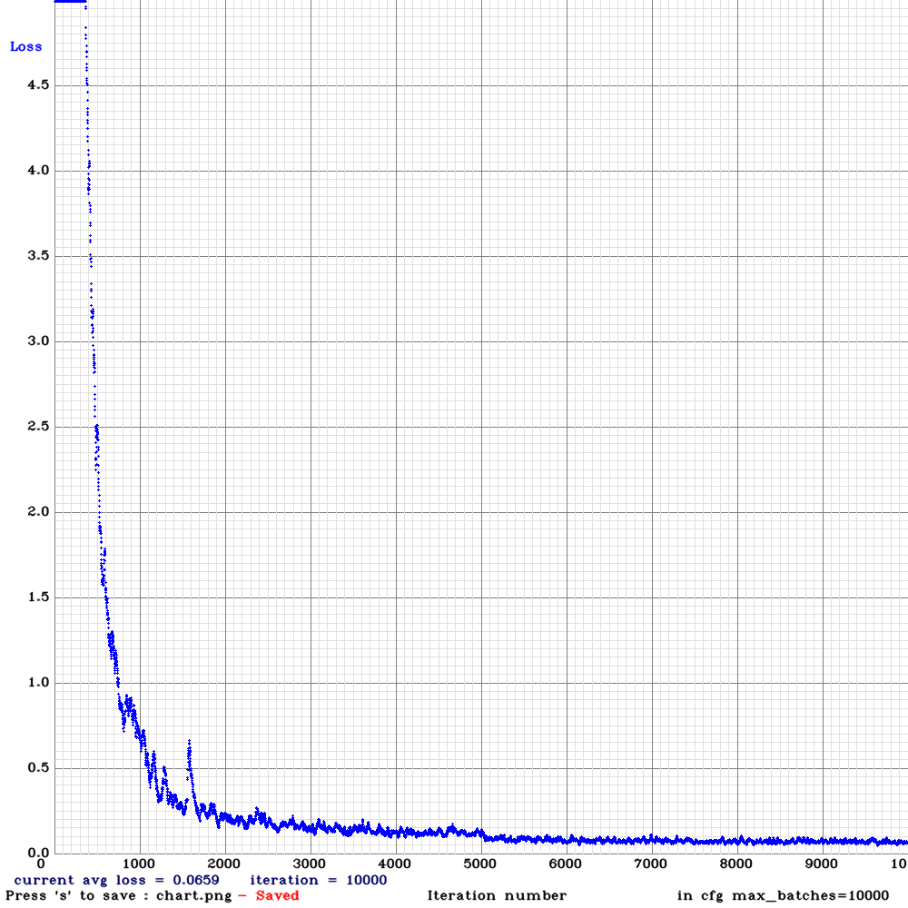

***Figure 6 Average loss of the Irregular Shape Detection Model.***

Furthermore, we also presented the result of visualization of hole detection by YOLOv3 in Table 5. The result of hole detected by YOLO is illustrated in second, fourth and sixth columns.

***Table 5 Hole labeling and result of hole detection of YOLOv3.***

|  |  |  |  |  |  |
| --- | --- | --- | --- | --- | --- |
| **Label of hole in original image** | **Result of hole detection** | **Label of hole in original image** | **Result of hole detection** | **Label of hole in original image** | **Result of hole detection** |
|  |  |  |  |  |  |
|  |  |  |  |  |  |
|  |  |  |  |  |  |
|  |  |  |  |  |  |
|  |  |  |  |  |  |

## Feature Extraction Methods

According to the experimental result from Chapter 4.1, pre-trained models cannot detect any features and objects which are similar to the hole in sensor network. Figure 7 is workflow of general hole object for model training.

We proposed two features for hole detection models. It included Graph Segmentation and Feature Transformation. And also, we proposed Specific Classification for hole classes. The detailed description of design of proposed models will be described in Chapter 4.2.1, Chapter 4.2.2 and Chapter 4.2.3 respectively.

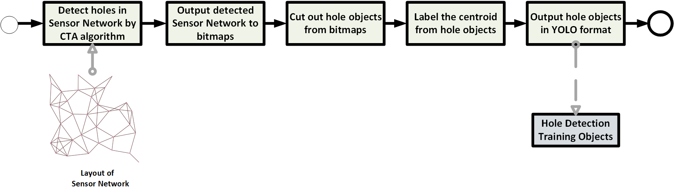

***Figure 7 The Workflow of generating hole object for model training***

### Graph Segmentation

The feature extraction for hole is crucial in Convolutional Neural Network (CNN) that is because the existing models for our application are unsatisfied as we evaluated. Therefore, we proposed approaches in order to extract features of holes according to the definition stated in CHAPTER 3.

The amount of dataset and significant feature of objects play an important characteristic in training object in Convolutional Neural Network (CNN). Thus, we proposed a feature extractor which is called Graph Segmentation which is an efficient method to collect numerous images of training object. With the use of the proposed extractor, we are able to prepare difference types of dataset of holes which can be used as the input of model training process. Moreover, the Contour Tracing Algorithm (CTA) is able to identify the region of holes in sensor networks. Therefore, we used Contour Tracing Algorithm (CTA) to cut out (segment) holes based on the regions identified by the Contour Tracing Algorithm (CTA).

That means, we cut holes in pieces from the output (bitmap) of Contour Tracing Algorithm (CTA). An example for hole segmentation from a sensor network is illustrated in Figure 8 in which 4 pieces of holes are segmented (cut out) from the sensor network. We then save these pieces of hole to bitmaps. Each piece of hole represents an image of training dataset. In addition, the evaluation for the feature extractor is described below.

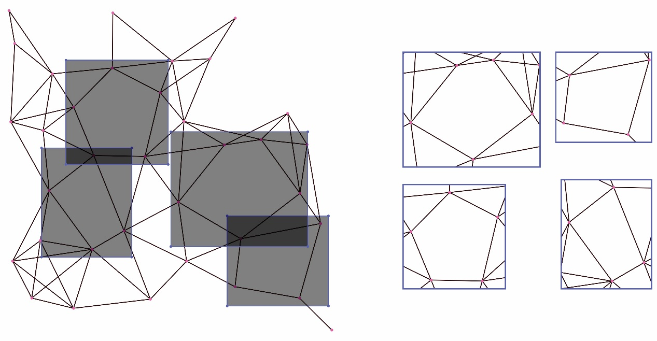

***Figure 8 An example of hole segmentation from a sensor network.***

In the experiment, we used Graph Segmentation as Feature Extractor to trained a model based on the configuration of YOLOv3 and we set ***max_batches*** to 6000. Moreover, the dataset of this model come from 5 datasets which are 500 nodes with average degrees 6, 8, 10, 12 and 15.

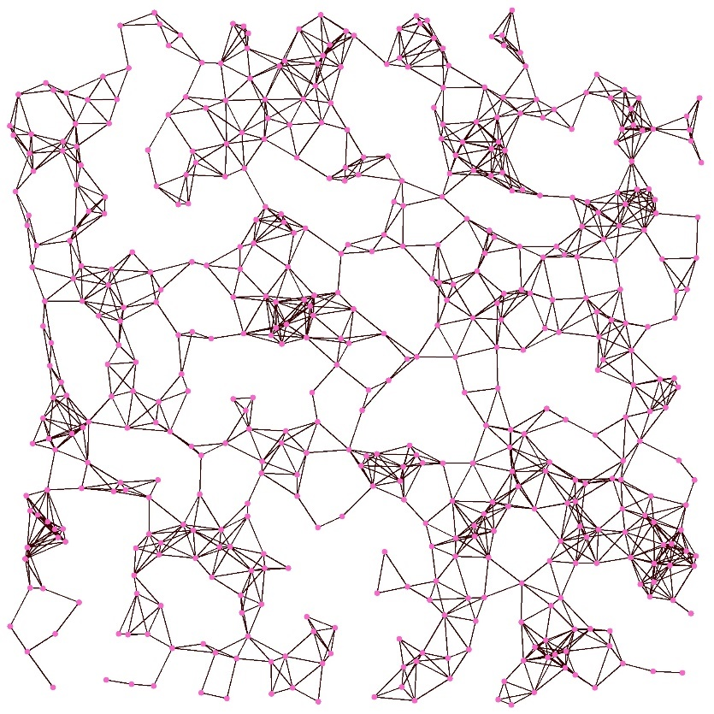

***Figure 9 The sparse sensor network used in the performance evaluation of Graph Segmentation.***

We selected a sparse sensor network as an example to describe our experimental results that is because such sensor network contains more holes than a uniform sensor network. Selected sparse sensor network contains 500 nodes and the average degree is 6**.** The visualization of the selected sparse sensor networks are illustrated in Figure 9. There are 94 holes inside the selected sparse network. Moreover, we added more dataset of holes by rotating 90˚ based on the 94 holes. Totally, 348 datasets are constructed and used as the input of model training. The screenshot of the datasets constructed according to above procedure are illustrated in Figure 10.

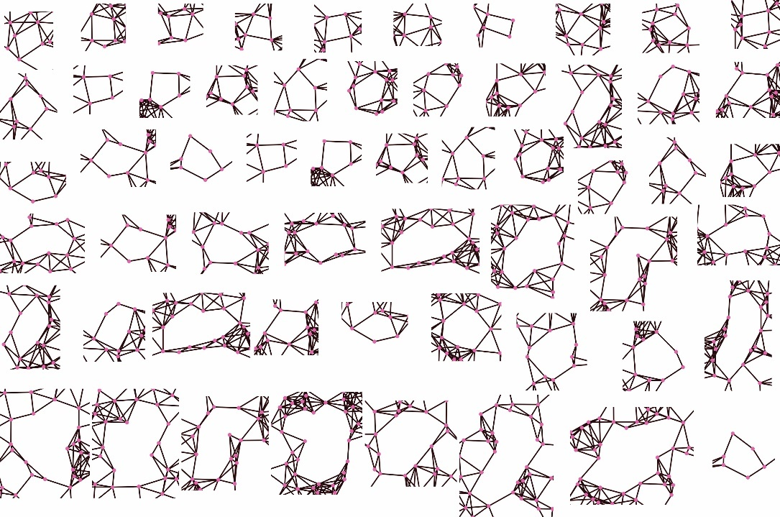

***Figure 10 The screenshot of dataset prepared for the model training.***

In fact, the ***max_batches*** can be terminated at 3000th iteration according to average loss illustrated in Figure 11. That is because the average loss has less than 0.0060 which is stabilized.

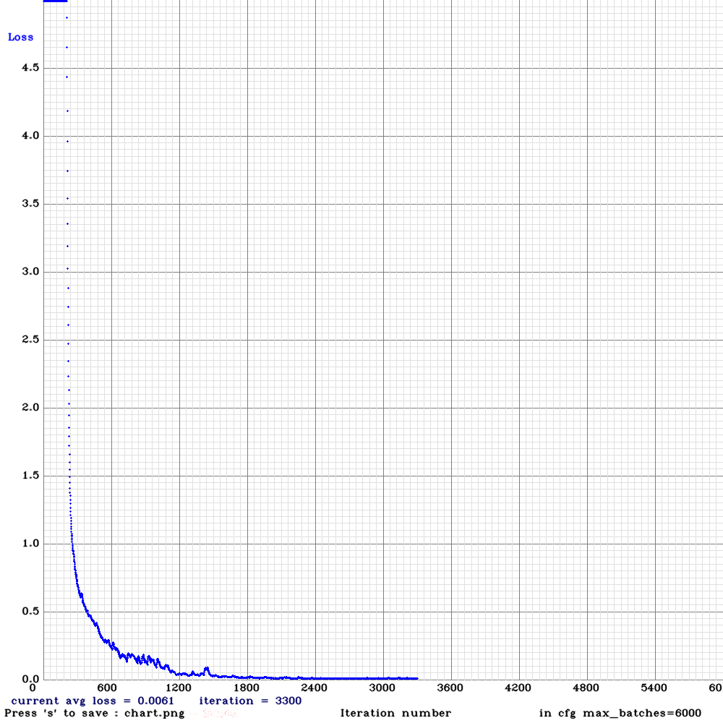

***Figure 11 Average loss of the Graph Segmentation Model.***

According to the experimental result shown in Table 6, intersection over union (IoU) and exceed 88% and mean average precision (mAP) exceed 99.71%. Therefore, experiment result showed the model can clearly predict a hole in which a sample of holes detected by Graph Segmentation in the selected sensor network is illustrated in Figure 12.

***Table 6 Average IoU and mAP of the Graph Segmentation Model.***

|  |  |  |
| --- | --- | --- |
| **Iteration** | **Average**  **Intersection Over Union**  **(IoU)** | **Mean Average Precision (mAP) @0.50** |
| 1000 | 76.63% | 99.14% |
| 2000 | 88.19% | 99.71% |
| 3000 | 88.52% | 99.71% |

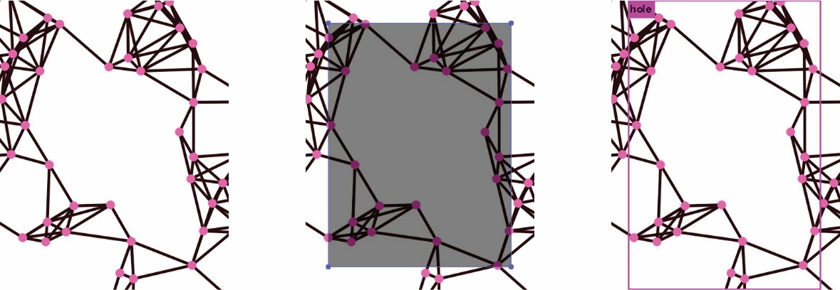

***Figure 12 The sample output of holes detected by Graph Segmentation.***

### Feature Transformation

Because the limitation of Graph Segmentation as discussed in Chapter 4.2.1, we proposed another feature extractor which is called Feature Transformation. It generates the image of holes from scratch rather than cut out holes from the output (bitmap) of Contour Tracing Algorithm (CTA). It can be done by parsing the result (a text file) of Contour Tracing Algorithm (CTA) rather than the bitmap output. That is, the position of nodes which located on the hole and the position of encircling node about holes can be parsed from the result (a text file) of Contour Tracing Algorithm (CTA). A bitmap of hole is then generated by Feature Transformation based on above information. The size, color, thickness of node and edge, even the resolution of images can be modified in the process of Feature Transformation. That is because we do not reply too much on the output (bitmap) of IP algorithm. Feature Transformation is able to create hole image in different foreground and background colors which can be used to create a diverse training image for model training. A comparison of images of Graph Segmentation and Feature Transformation is illustrated in Figure 13.

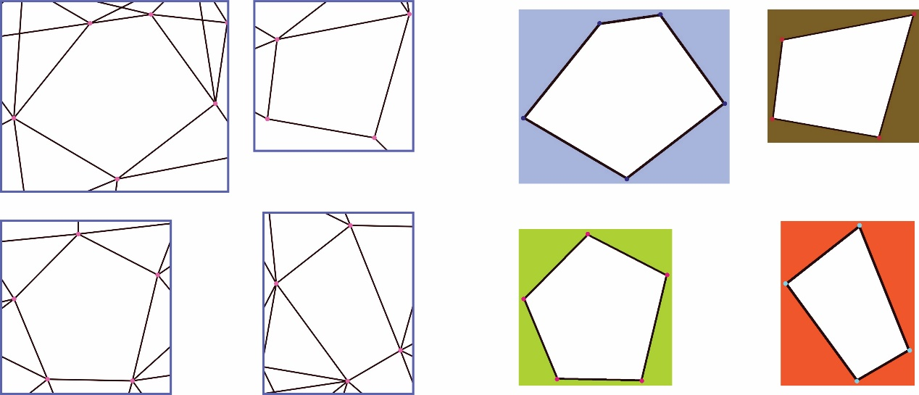

***Figure 13 The comparison of images generated by Graph Segmentation and Feature Transformation.***

In the experiment, we trained the feature of Graph Segmentation Model based on the configuration of YOLOv3 and we set ***max_batches*** to 6000. Moreover, the dataset of this model come from 5 datasets which are 500 nodes with average degrees 6, 8, 10, 12 and 15.

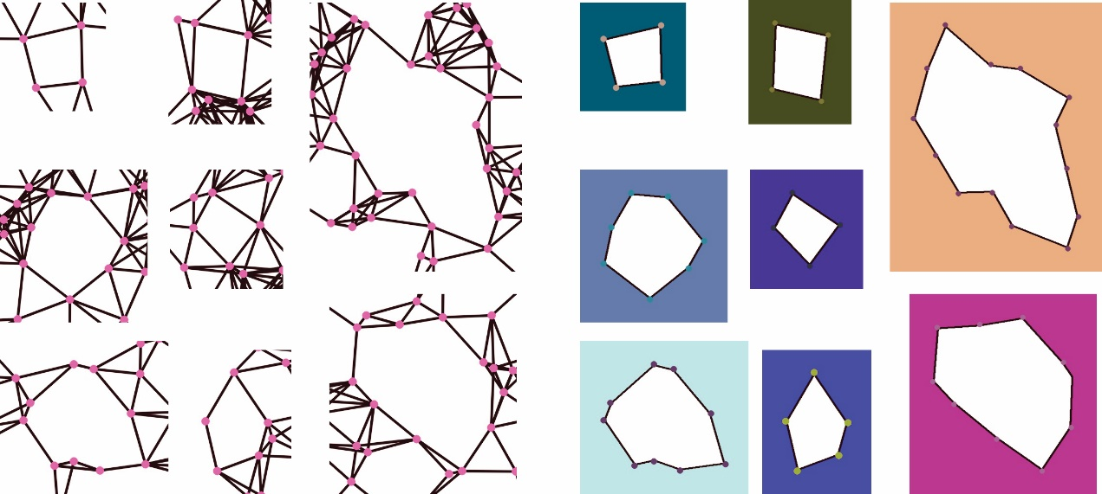

***Figure 14 Holes with different background color.***

The dataset has 348 holes. Moreover, holes in dataset are identical shape and size except random node and background color. The samples of holes in these datasets are illustrated in Figure 14. Moreover, the model training can be terminated at 3400th iteration. Because of the average loss is less than 0.0080 which is stabilized as illustrated in Figure 15.

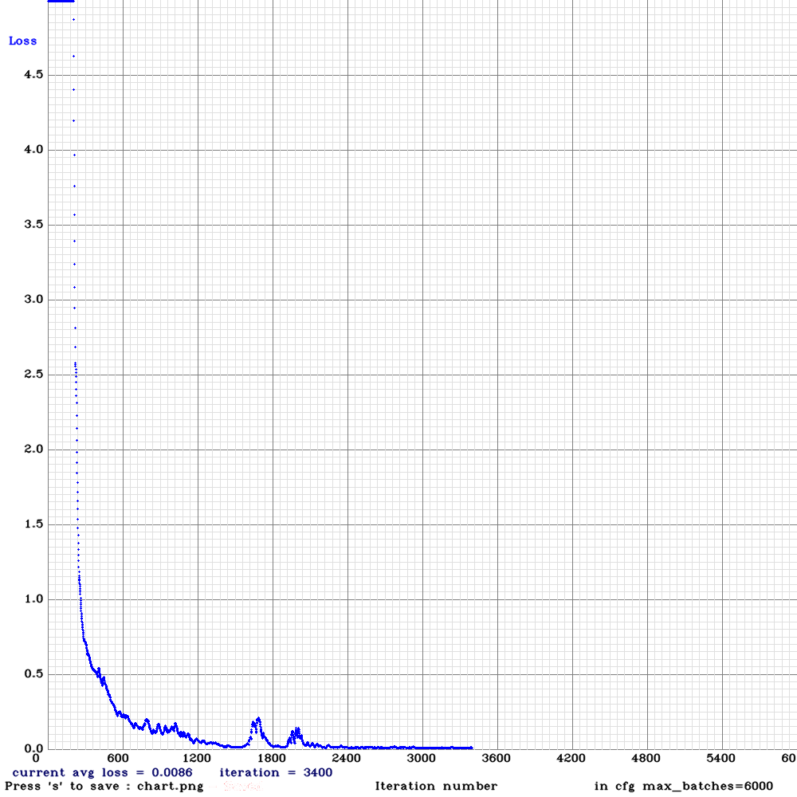

***Figure 15 Average loss of the Feature Transformation Model***.

The detailed average of intersection over union (IoU) and mean average precision (mAP) are summarized in ***Table 7*** In which the mean average precision (mAP) is 91.47% and mean average precision (mAP) is 98.25% at 3000th iteration. Therefore, the training model is able to detect the hole object that a sample output of hole prediction by using Feature Transformation model is illustrated in Figure 16.

***Table 7 Average IoU and mAP of the Feature Transformation Model.***

|  |  |  |
| --- | --- | --- |
| **Iteration** | **Average**  **Intersection Over Union**  **(IoU)** | **Mean Average Precision (mAP) @0.50** |
| 1000 | 68.30 % | 95.93 % |
| 2000 | 86.58 % | 98.25 % |
| 3000 | 91.47 % | 98.25 % |

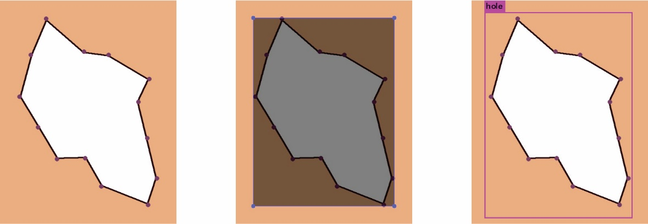

***Figure 16 The sample output of holes detected by Feature Transformation.***

In the comparison of Graph Segmentation as Feature Extractor and Feature Transformation as Feature Extractor, two models have slimily Mean Average Precision (mAP) according to Table 6 and Table 7. But Feature Transformation model has higher Average Intersection Over Union (IoU). Through The two models predict each other's training images, Graph Segmentation model cannot completely to predict Feature Transformation as Feature image. Figure 17 which is Graph Segmentation model fail predictions in Feature Transformation as Feature image. The loss predictions are all quadrilaterals. On the other hand, Feature Transformation model is able to predict whole Graph Segmentation as Feature images. Figure 18 is the sample datasets which cannot be detected as holes by Graph Segmentation as Feature Extractor.

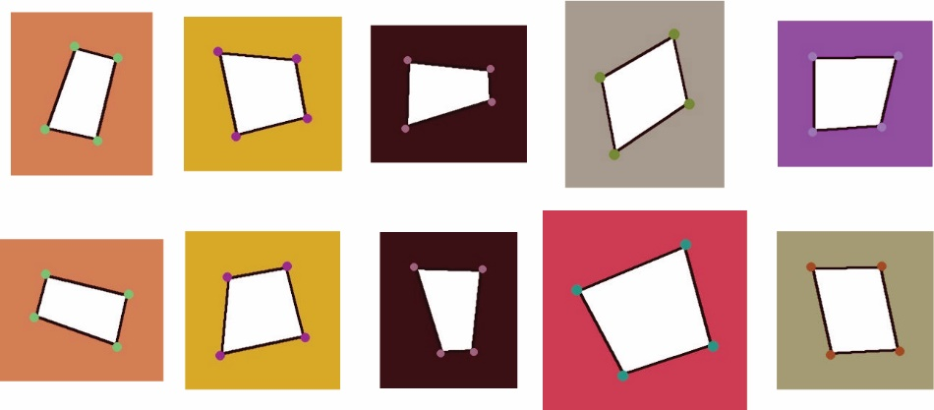

***Figure 17 Samples that cannot be detected as holes by Graph Segmentation model.***

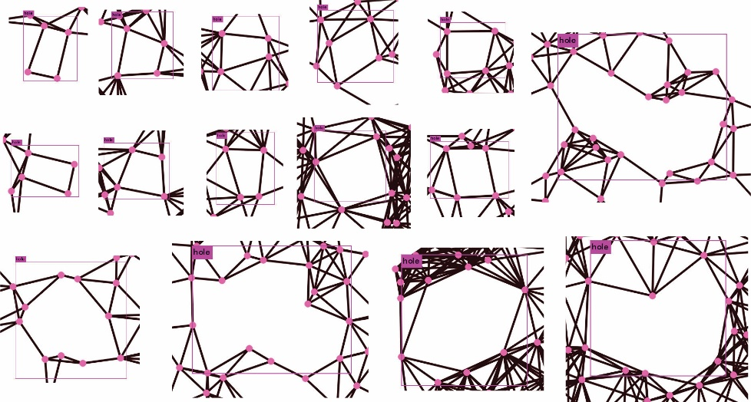

***Figure 18 The sample of prediction Graph Segmentation by using Feature Transformation model.***

### Specific Classification

Specific Classification is based on Graph Segmentation and Feature Transformation which is introduced in Chapter 4.2.1 and Chapter 4.2.2. It is designed in a way to construct the images of holes in groups with the use of the number of nodes actually located on the boundary of hole. That mean, the objective of this Feature Transformation is based on the information of nodes which used to encircle a hole. For instant, holes with 4 boundary nodes belongs to the first group, holes with 5 boundary nodes belongs to second group, and so on.

However, holes with 6 or even more boundary nodes can enclose many possibilities polygons, these are difficult to collect the shape of hole. Therefore, the hole object classified four types of categories in our works (see Figure 19). It is included hole with 4 boundary nodes, hole with 5 boundary nodes, hole with 6 boundary nodes, and hole with simple polygon. Because of a hole with above of 6 boundary nodes is similar with simple polygon [30] which is geometry definition.

In the evaluation, we used Feature Transformation as Feature Extractor and classify the categories of training dataset. The evaluation is described in the below.

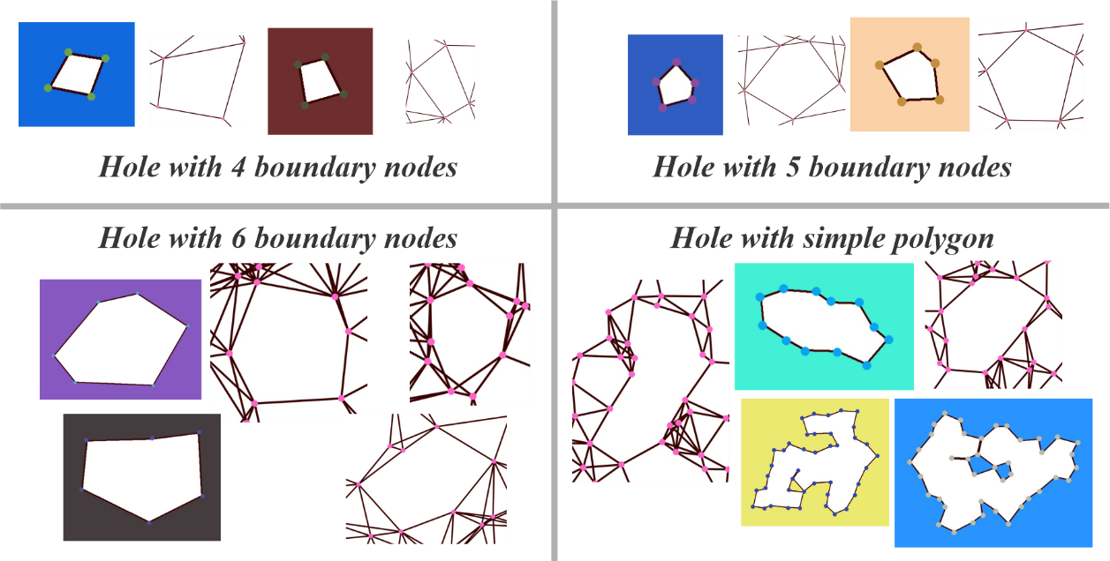

***Figure 19 The four types of categories in hole object.***

We based on Feature Transformation created training dataset to modify the hole classes. According to the introduction, we created 4 difference hole classes. It is included 4 nodes Hole, 5 nodes Hole, 6 nodes Hole and Hole with 7 nodes and more. The Feature Transformation labelled and Specific Classification is illustrated in Figure 20.

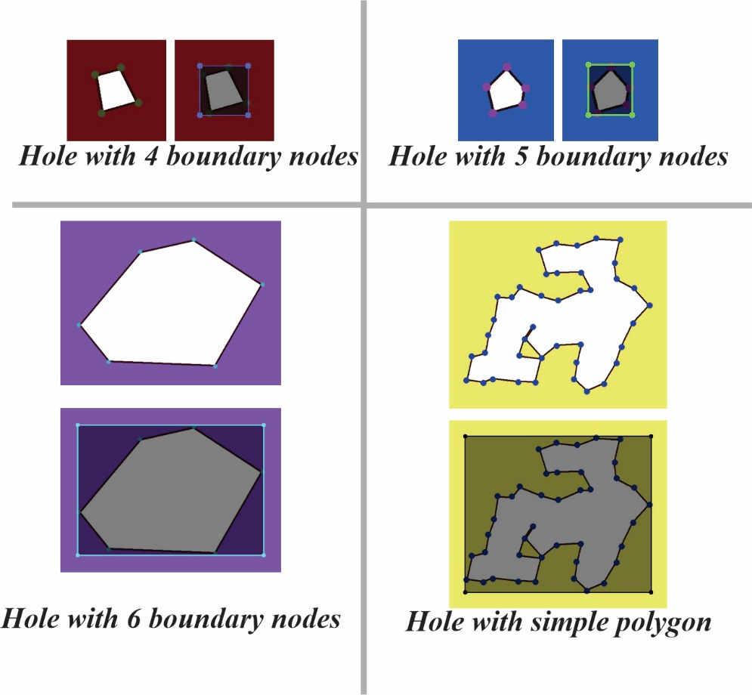

***Figure 20 The labeled Feature Transformation by Specific Classification.***

The model we set ***max_batches*** to 20000 and the model training has terminated at 3600th iteration. Because of the average loss is less than 0.02 which is stabilized as illustrated in ***Figure 21***.

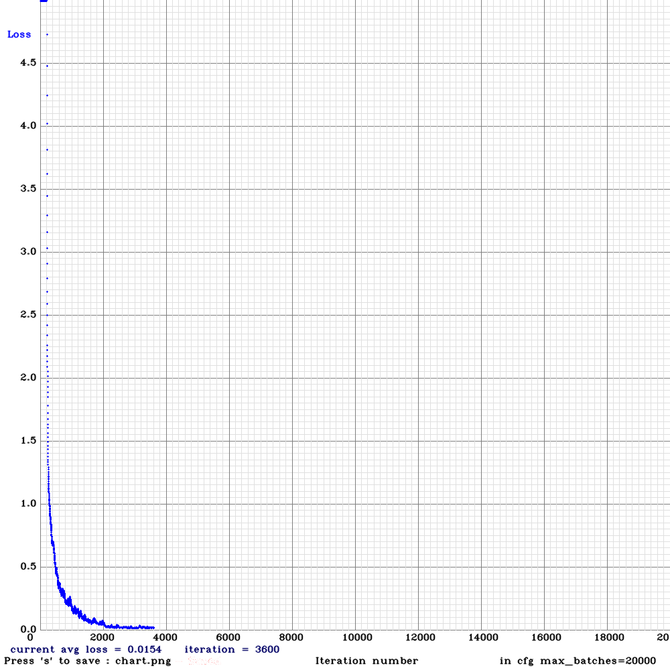

***Figure 21 Average loss of the Feature Transformation with Specific Classification Model.***

The detailed average of intersection over union (IoU) and mean average precision (mAP) are summarized in Table 8. The average of intersection over union (IoU) is 87.27% and Mean Average Precision (mAP) is 99.59% at 3000th iteration. Feature Transformation with Specific Classification achieves the smallest average of intersection over union (IoU) among three models we proposed. That means the variance of boxes (region of hole) between detected holes and the labelled holes is high or the hole is unable to detect. In addition, the Mean Average Precision (mAP) of Feature Transformation with Specific Classification is higher than Feature Transformation as Feature Extractor but smaller Feature Transformation model as Feature Extractor. The Mean Average Precision (mAP) of Feature Transformation with Specific Classification does not drop significant even though we did hole classes in all dataset images.

***Table 8 Average IoU and mAP of the Feature Transformation with Specific Classification Model***

|  |  |  |
| --- | --- | --- |
| **Iteration** | **Average**  **Intersection Over Union**  **(IoU)** | **Mean Average Precision (mAP) @0.50** |
| 1000 | 67.53% | 70.45% |
| 2000 | 83.46% | 99.52% |
| 3000 | 87.27% | 99.59% |

A sample output of each hole classes prediction by using Feature Transformation with Specific Classification model is illustrated in Figure 22.

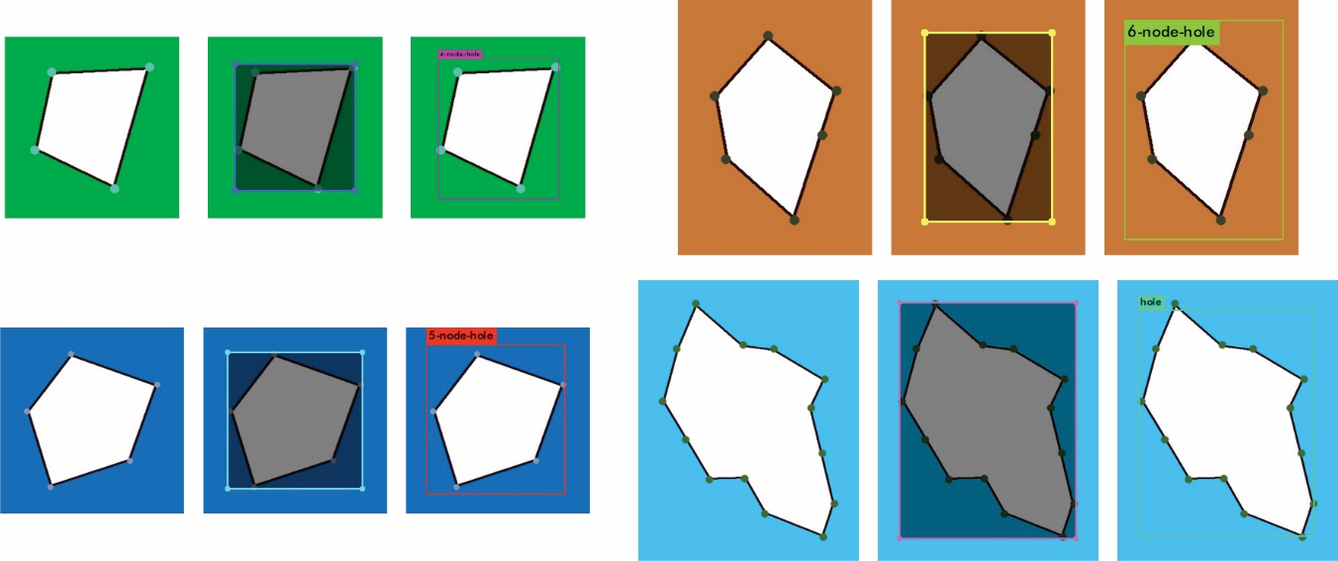

***Figure 22 The sample output of holes detected by Specific Classification model.***

Feature Transformation with Specific Classification model also able to predict Graph Segmentation holes image, Figure 23 is the sample output holes predictions. Actually, the model cannot perfectly and correctly to predict whole Graph Segmentation hole images. The first reason is that the model did not learn any Graph Segmentation images, so it cannot likely to predict the hole by Graph Segment. The second reason is insufficient training image. Feature Transformation originally have 348 images for training one classes. After Specific Classification, the average is 87 images for each classes, the image sets of 6 nodes hole is just 10 images.

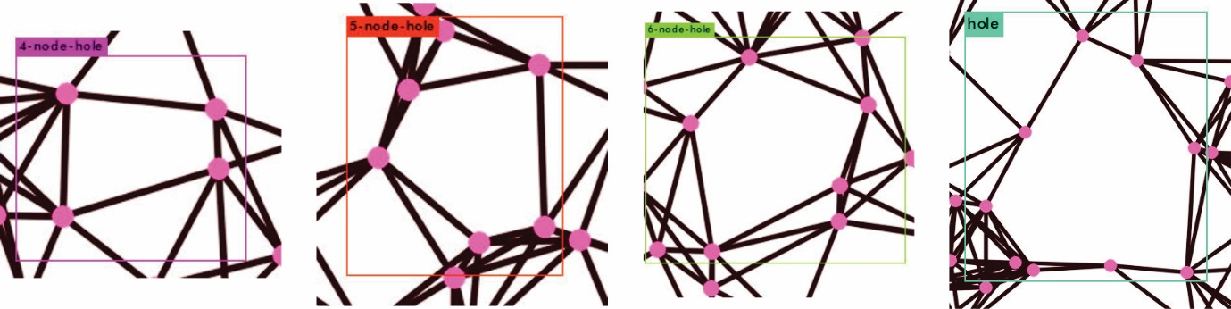

***Figure 23 The sample Graph Segmentation holes detected by Feature Transformation with Specific Classification.***

## Datasets Preparation and Model Training

According to experiment of Chapter 4.1, we summed up two features for training hole detection model and Specific Classification. Therefore Chapter 4.2 will be described that using two Feature Extractor to trained a Convolutional Neural Network for Hole Detection in sensor network.

After output predicted image, we conduct Boundary Identification and node identification Recognition for identifying the Boundary node of the hole. The application will be described in Chapter 4.4

Based on experiment of Chapter 4.2, Graph Segmentation and Feature Transformation are able to generate hole images for training hole detection model. But those models still cannot predict hole object in sensor network. Therefore, we proposed strengthen dataset for training model. The training dataset combined two features and sensor network with labelled hole, also Figure 24 is illustrated the features in training dataset. Moreover, the general workflow of model training for proposed models is illustrated in Figure 25. The experiment of hole detection model in sensor networks is described in Chapter 5. The performance evaluation of hole detection model is described in 5.3 respectively.

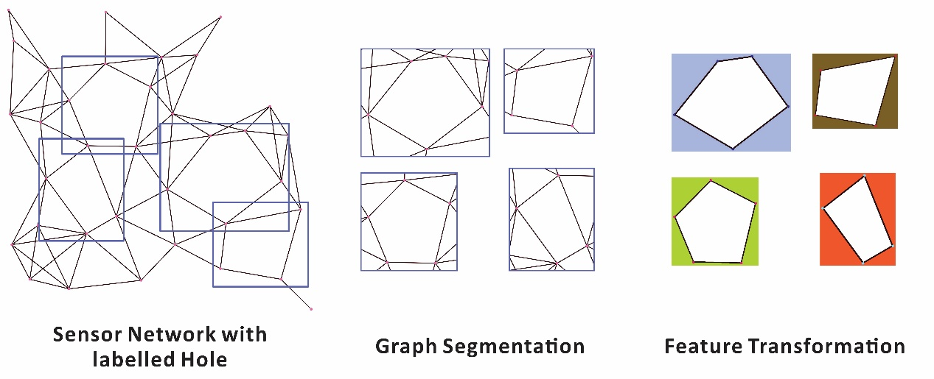

***Figure 24 Three types of features in Training Dataset.***

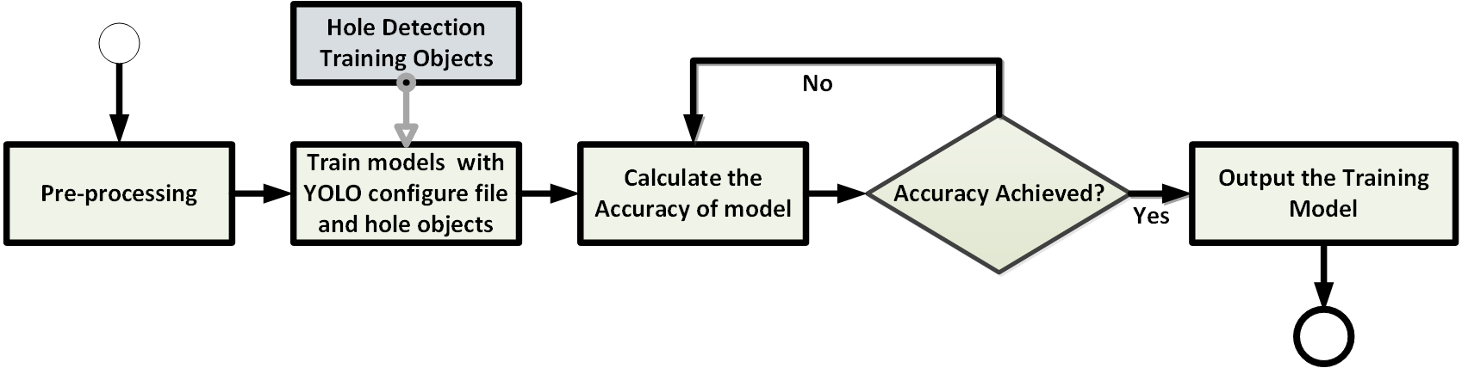

***Figure 25 The general workflow of model training for proposed models.***

Through the experiment of Chapter 4.2, we concluded two features is effective for training hole detection model in sensor network. Therefore, Chapter 5 we used two Feature Extractor and the sensor network with label hole to train a model be the hole detection model in sensor network.

In the experiment, we trained the model also based on the configuration of YOLOv3 and we set ***max_batches*** to 6000 at first. But average loss of the training model is still high at 6000th iteration (see Figure 26 (a)). So, we set ***max_batches*** to 12000 and the average loss is 0.1657(see Figure 26 (b)).

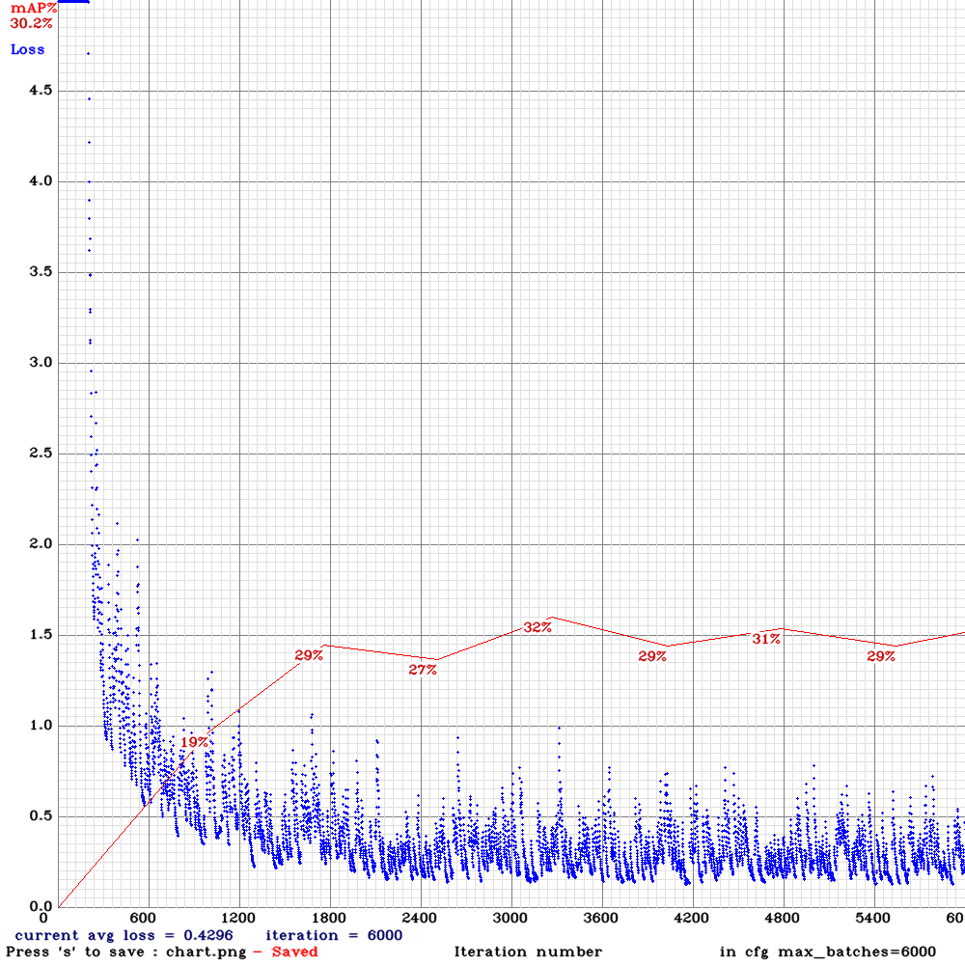

***(a)***

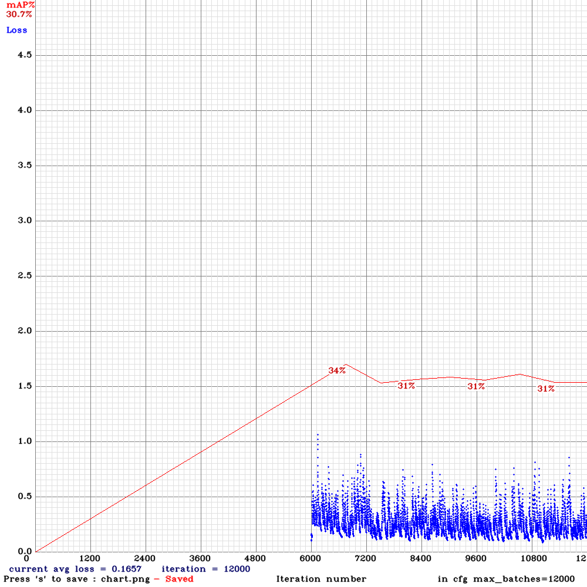

***(b)***

***Figure 26 Average loss of the Hole Detection Model in Sensor Networks at iteration 1 to 6000 (a) and***

***iteration 6000 to 12000 (b).***

The detailed average of Intersection Over Union (IoU) and Mean Average Precision (mAP) are summarized in Table 9. The average of Intersection Over Union (IoU) is 57.46% and Mean Average Precision (mAP) is 30.73% at 12000th iteration. Because of the average of Intersection Over Union (IoU) is the highest in those iteration and over 50%. Therefore, we stopped training the model at 12000th iteration.

***Table 9 Average IoU and mAP of the Hole Detection Model in Sensor Networks***

|  |  |  |
| --- | --- | --- |
| **Iteration** | **Average**  **Intersection Over Union**  **(IoU)** | **Mean Average Precision (mAP) @0.50** |
| 1000 | 31.75% | 19.28% |
| 2000 | 41.61% | 28.76% |
| 3000 | 49.29% | 29.51% |
| 4000 | 49.57% | 30.10% |
| 5000 | 48.98% | 31.39% |
| 6000 | 49.92% | 30.21% |
| 7000 | 49.87% | 33.20% |
| 8000 | 56.99% | 32.31% |
| 9000 | 56.86% | 30.54% |
| 10000 | 57.31% | 29.86% |
| 11000 | 57.39% | 29.42% |
| 12000 | 57.46% | 30.73% |

## Application from Sensor Networks

As described in Figure 3, once we retrieve the predication result of hole detection by the proposed model of YOLO, we need to identify the boundary of detected hole. Because of we are able to retrieve the center (x-axis and y-axis) of holes in a sensor network. Instant segmentation is then applied at the center of hole using Flood Fill algorithm. Here, filled regions represent holes detected by the proposed model of YOLO. An example is illustrated in Figure 27 in which the gray boxes are the prediction result of hole by the proposed model of YOLO. Green regions are the result of Instant Segmentation which is flood filled at the center of holes.

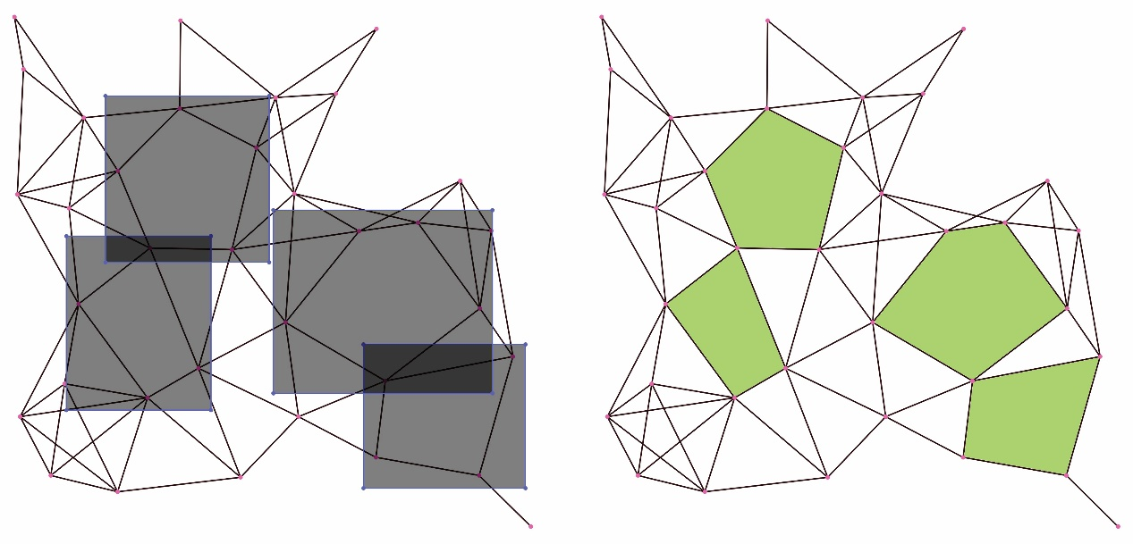

***Figure 27 An example of instant segmentation of a sensor network.***

After instance Segmentation, we separate the mask of filled area to node identifier recognition, as illustrated inFigure 28. Therefore, we can likely to get the contour of hole. Node Identifier Recognition is a process to find the node located on holes. Suppose a node is closed or inside the boundary of hole, then the node is located on the hole. Through two steps, the system finally able to identify the boundary nodes of detected hole in sensor networks.

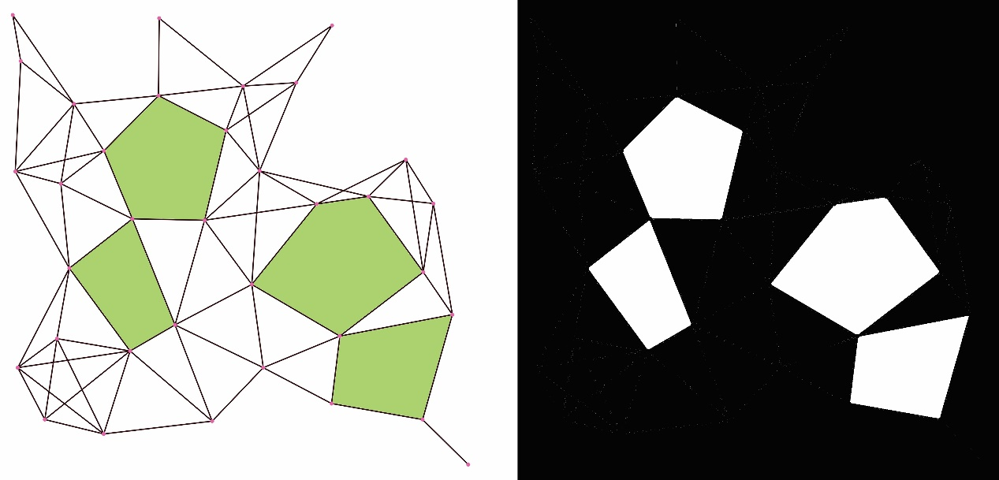

***Figure 28 An example of instance segmentation mask from a sensor network.***

# EXPERIMENTS

To evaluate the proposed algorithms, we implemented a simulation environment using the Python programming language. In a sensor network, a number of parameters can influence experimental results, including the total number of nodes in the sensor network, the number of edges per node and the edge distribution within the sensor network. For instant, the higher the number of nodes in a sensor network, the larger the amount of memory consumed and the longer the execution time. We conducted our experiments on a computer using an Intel Core i7-6700HQ processor, graphics card NVDIA GeForce GTX 1070 with 16 GB of memory for Contour Tracing Algorithm (CTA). Moreover, we conducted our experiments to train models of YOLO on a computing using Intel Core i7-6700HQ processor, graph card NVDIA GeForce GTX 960M with 16 GB of memory.

## Dataset Preparation

We considered various sensor networks in evaluating the performance and execution time for hole detection. These sensor networks are called ground truth dataset. For our experiments, we focused on sensor networks with sparse and uniform distributions. Figure 29 (a) and (b) illustrate examples of a sparse sensor network and a uniform sensor network which were captured from the ground truth datasets, respectively, with the same total number of nodes $\left(n\right)$ and average degree $\left(d\right)$. In addition, uniform and sparse ground truth datasets are donated as $D_{U}$ and $D_{S}$ respectively. In both ground truth datasets, we set the total number of nodes $n$ to 500, 1,000, 2,000 and 3,000. We also set the average degrees of ground truth datasets $d$ to 6, 8, 10, 12 and 15 for the generation of sensor network. Overall, 40 topologies of (uniform and sparse) sensor network were generated for the experiments based on all of the possible combinations of $n$ and $d$. Moreover, the generation of uniform and sparse ground truth datasets are adopted from [18] and generated by a toolkit CNCAH Network Generator [31].

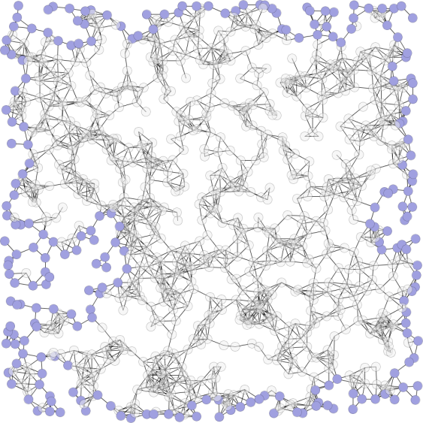 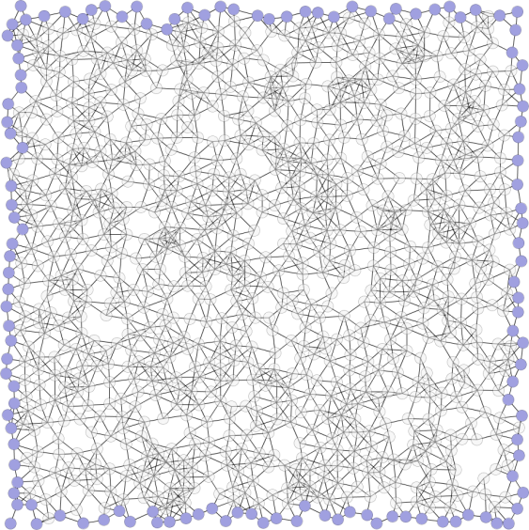

(a) (b)

***Figure 29 Example of (a) sparse sensor network, (b) uniform sensor network.***

Moreover, the training dataset come from 20 datasets which are 500 nodes, 1000 nodes, 2000 nodes and 3000 nodes with their average degrees 6, 8, 10, 12 and 15. Each dataset generated sparse (see Table 10) and uniform (see Table 11) with sensor networks. Therefore, the training dataset totally has 40 sensor networks.

The training sensor networks totally have 2705 hole objects. We used approaches which is Graph Segment and Feature Transformation to each hole object. Afterward, the hole objects will be classified into corresponding categories. Hole with 4 boundary nodes has 2337 hole objects, hole with 5 boundary nodes has 1201 hole objects, hole with 6 boundary nodes has 661 hole objects, and hole with simple polygon has 1211 hole objects.

***Table 10 The sparse sensor networks used to train hole detection model.***

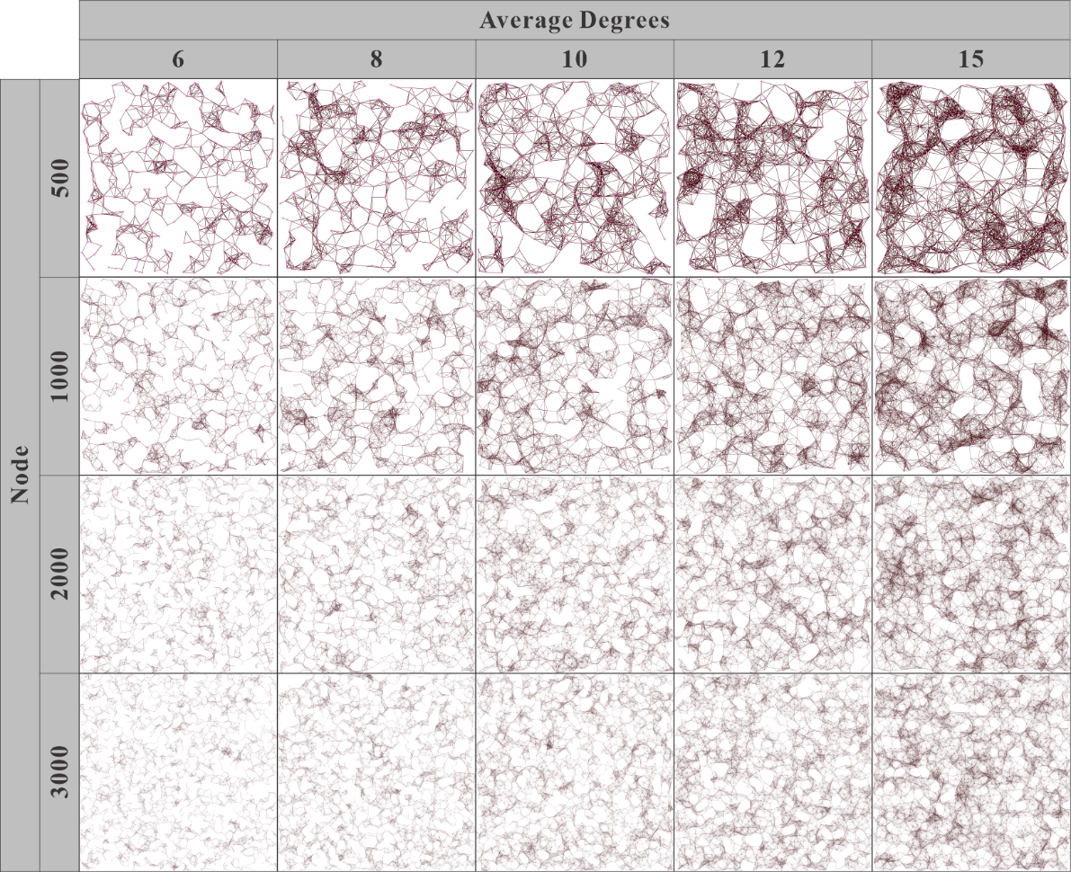

***Table 11 The uniform sensor networks used to train hole detection model.***

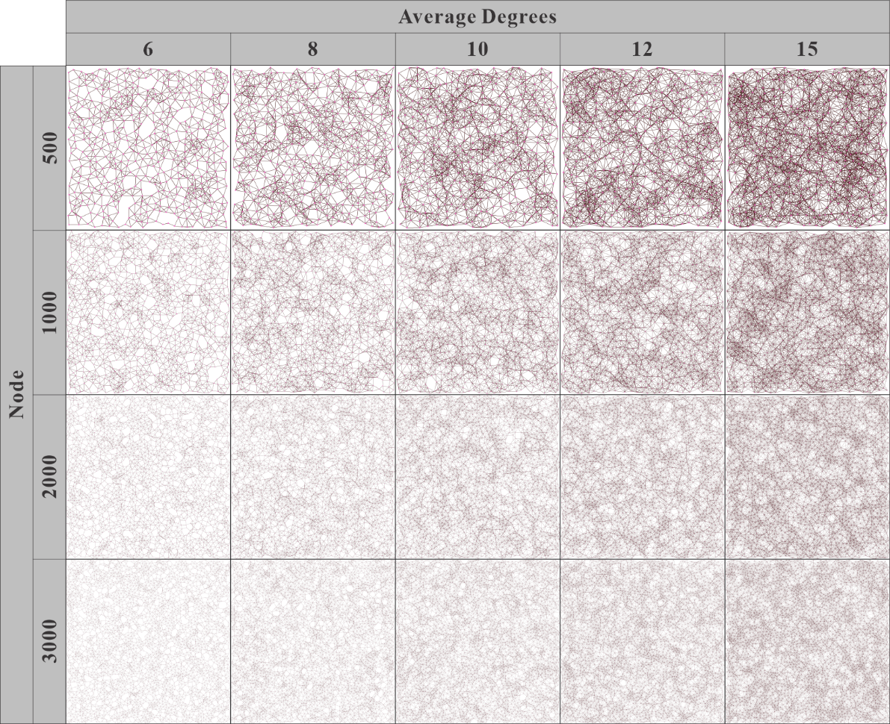

## Experiment Settings

In additional to the ground truth datasets, ten force-directed algorithms are implemented in our experiments. They are Fruchterman Reingold (FR) algorithm [9], Kamada Kawai (KK) algorithm [10], Davidson Harel (DH) algorithm [11], ForceAtlas2 (FA2) algorithm [12], force-directed edge bundling (FDGE) algorithm [13], Fruchterman Reingold with range extension (FRR) algorithm [14], CWBound algorithm [15], JIGGLE algorithm [16], LinLog algorithm [17] and Kamada Kawai with multiple node selection and decaying stiffness (KK-MS-DS) algorithm [18].

In our experiments, the default size of the drawing frame (canvas) of force-directed algorithms was 600 $×$ 600. Moreover, the algorithm was allowed to execute for up to 600 seconds. For each input network topology (ground truth dataset), every node was assigned a random visual position within the drawing frame. Force-directed algorithms then produce a layout per iteration in which is layout is stored and used to evaluate the performance of hole detection. Moreover, attributes and notations used in our experiments are summarized in Table 12.

***Table 12 Attributes and notations used in the experiments.***

|  |  |
| --- | --- |
| **Notation** | **Description** |
| $$n$$ | Number of nodes in the network |
| $$d$$ | Average degree of the network |
| $${Hole}_{P}$$ | The node which is located on the hole. |
| $${Hole}_{N}$$ | The node which is not located on the hole |
| $${Ground}_{P}$$ | The node which is located on the hole of ground truth dataset. |
| $${Ground}_{N}$$ | The node which is NOT located on the hole of ground truth dataset. |
| $${Ground}_{U}$$ | The layout of a uniform sensor network. |
| $${Ground}_{S}$$ | The layout of a sparse sensor network. |
| $${FD}_{P}$$ | The node which is located on the hole of the layout of force-directed algorithm. |
| $${FD}_{N}$$ | The node which is NOT located on the hole of the layout of force-directed algorithm. |
| $${FD}_{U}$$ | The layout of force-directed algorithms in which the input topology is a uniform sensor network. |
| $${FD}_{S}$$ | The layout of force-directed algorithms in which the input topology is a sparse sensor network. |

We showed an example of result of hole detections of a ground truth data and the layout of a force-directed algorithm in Figure 30 (a) and Figure 30 (b) respectively. Figure 30 (a) illustrated the result of hole detection from the layout of sparse ground truth dataset ${Ground}_{S}$ with $n=1000$ and $d=500$. Figure 30 (b) illustrated the result of layout ${FD}_{S}$ which is captured at 600th second of the KK-MS-DS algorithm with $n=1000$ and $d=500$.

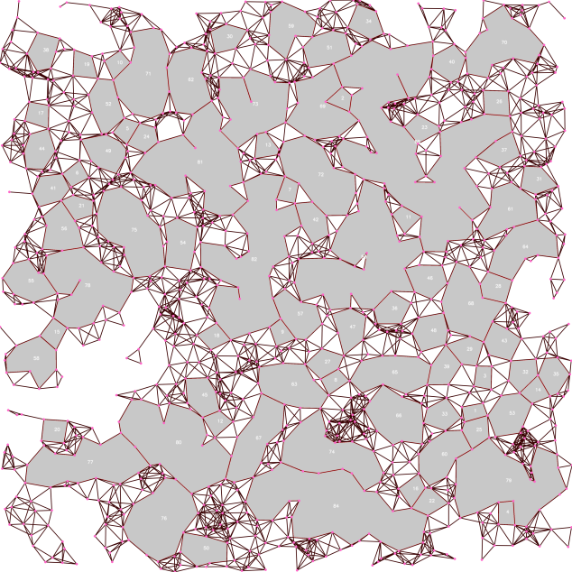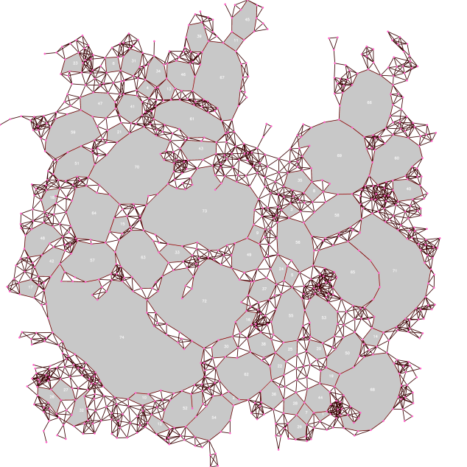

(a) (b)

***Figure 30 An example of result of hole detection of (a) ground truth dataset, (b) layout of force-directed algorithm.***

The size of canvas of force-directed algorithms was set to 600 $×$ 600. That mean, the position of nodes in the layout of force-directed algorithms was placed in a surface with width 600 and height 600. However, such canvas size is hard for hole detection because the size of canvas is too small especially when the number of nodes and average degree are high. That is because too many edge crossing is in the layout and the resolution of layout is not enough for the hole detection. For instant, a layout with high number of nodes and average degree is illustrated in Figure 31. Therefore, we used a scaling technique to enlarge the size of canvas of layout in order to enable the capability for hole detection. The scaling equation used in our experiments is shown in

$$L_{width}\left(n\right)=4×n; L_{height}\left(n\right)=4×n$$

where $L_{width}\left(n\right)$ and $L_{height}\left(n\right)$ are the scaled resolution of canvas for the width and height of layout respectively. $n$ is the number of nodes in the layout.

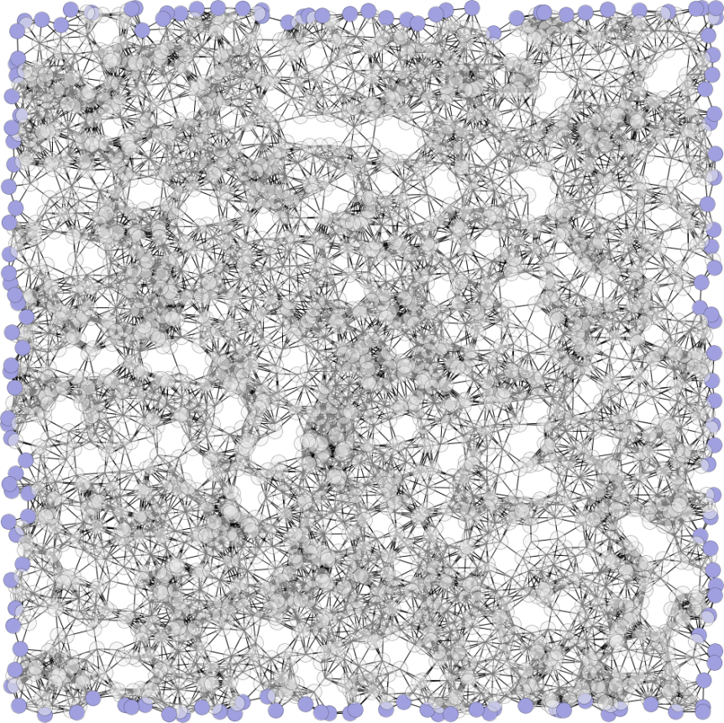

***Figure 31 An example of layout with high number of nodes and average degree.***

## Performance Evaluation of Hole Detection in Sensor Network by Convolutional Neural Network

The performance evaluation of hole detection in sensor network with Convolutional Neural Network (CNN) is based on layout of ground truth datasets and the layout of force-directed algorithms. The description of performance evaluation criteria is shown in Table 13. In this experiment, a time limit was assigned to force-directed algorithms as their stopping criteria. That is, force-directed algorithms produce the layout of sensor network until the time limit reached that does not stop by a maximum iteration or achieve to a lower energy.

***Table 13 Performance evaluation criteria of Node Identifier Matching.***

|  |  |  |
| --- | --- | --- |
| **Criteria** | **Description** |  |
| Sensitivity | ${Ground}_{P}$ correctly identified as ${FD}_{P}$ | The higher the better |
| Specificity | ${Ground}_{N}$ correctly identified as ${FD}_{N}$ | The higher the better |
| Execution time | Total amount of execution time that the algorithm ran in seconds | 600 seconds in our experiments |

The definition of sensitivity and specificity is defined as follows:

Sensitivity = $\frac{TP}{TP+FN}$

Specificity = $\frac{TN}{FP+TN}$

where $TP$ indicates the node is ${Hole}_{P}$ in both ground truth dataset and the layout of force-directed algorithm. $TN$ indicates the node is ${Hole}_{N}$ in both ground truth dataset and the layout of force-directed algorithm. $FP$ indicates the node is ${Hole}_{P}$ in the layout of force-directed algorithm. However, the node is ${Hole}_{N}$ in the ground truth dataset. $FN$ indicates the node is ${Hole}_{N}$ in the layout of force-directed algorithm. However, the node is ${Hole}_{P}$ in the ground truth dataset.

We did not measure the accuracy of our algorithms because there are problems with accuracy. When a large network is used for hole detection, the number of ${Hole}_{N}$ nodes can significantly influence the accuracy. In our application, only few number of nodes are ${Hole}_{P}$. This means that accuracy depends on the sum of the true positive number ($TP$) and the true negative number ($TN$) divided by the total number of nodes examined. If the true negative number ($TN$) is high, then the accuracy is high. Accuracy will yield misleading our experimental results if the number of ${Hole}_{N}$ and ${Hole}_{P}$ is unbalanced. Precisely, this case occurs when the numbers of ${Hole}_{N}$ and ${Hole}_{P}$ vary greatly. It cannot reflect the real performance of algorithms as applied to hole detection. Therefore, we verified the sensitivity of the ${Hole}_{P}$ in which high sensitivity indicates the ${Ground}_{P}$ correctly identified as ${FD}_{P}$ which is defined as the total number of correctly identified positive examples divide to the total number of positive examples.

According to the observation of experimental results, the quality of the result of force-directed algorithm could be variant even with identical execution time. The situation is illustrated in Figure 32 in which both Figure 32 (a) and Figure 32 (b) have same number of nodes and average degree. The detected holes are marked by a pink frame and regions of hole are filled by a green color.

Therefore, we evaluated the performance of hole detection algorithm with respect to the result of force-directed algorithm, number of nodes and average degree.

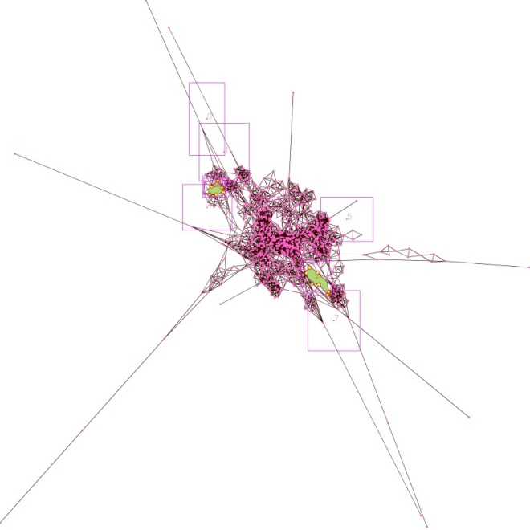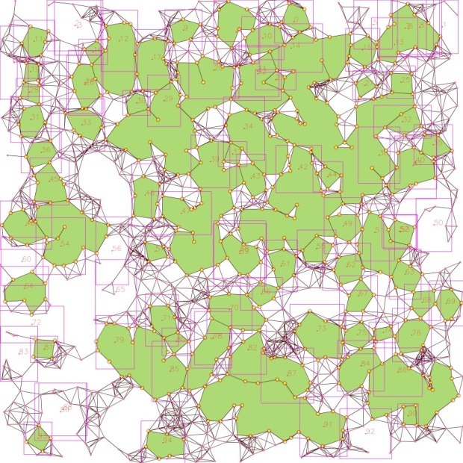

(a) (b)

***Figure 32 Workflow of performance evaluation of hole detection in sensor network with Convolutional Neural Network (CNN).***

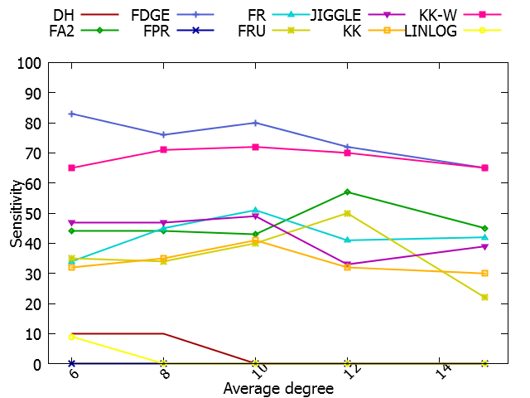

(a)

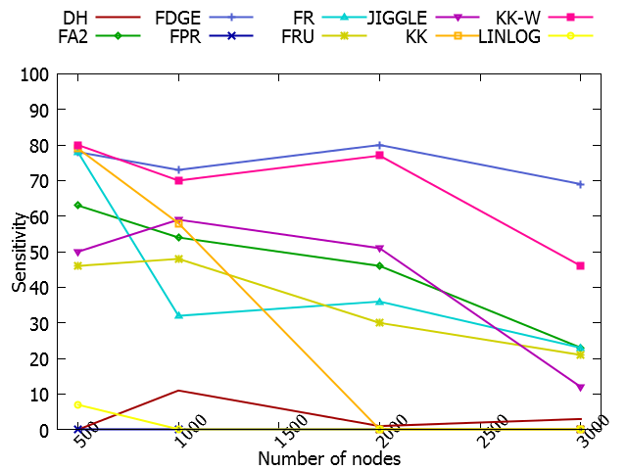

(b)

***Figure 33 Sensitivity of hole detection of force-directed algorithms and (a) number of nodes and (b) average degree in sparse sensor network.***

***Figure 33*** (a) illustrated the sensitivity of hole detection in terms of variant number of force-directed algorithms and average degree. The experimental result of hole detection was plotted against the force-directed algorithms and with average degree 6, 8, 10 and 12 and 15 in sparse sensor network. ***Figure 33*** (b) illustrated the sensitivity of hole detection in terms of variant number of force-directed algorithms and number of nodes. The experimental result of hole detection was plotted against the force-directed algorithms and with number of nodes 500, 1000, 2000 and 3000 in sparse sensor network.

The experimental results revealed that KK-MS-DS and FDGE algorithms achieved the highest sensitivity regardless of the average degree and number of nodes in sparse sensor networks. However, DH and LinLog algorithms achieved the lowest sensitivity regardless of the average degree and number of nodes. The sensitivity of FA2, FRR, FRU, KK, JIGGLE and FR algorithms do not have significant improvement with number of nodes 500, 1000, 2000 and 3000. However, the sensitivity of KK algorithm is dropped when the number of nodes is larger than 2000.

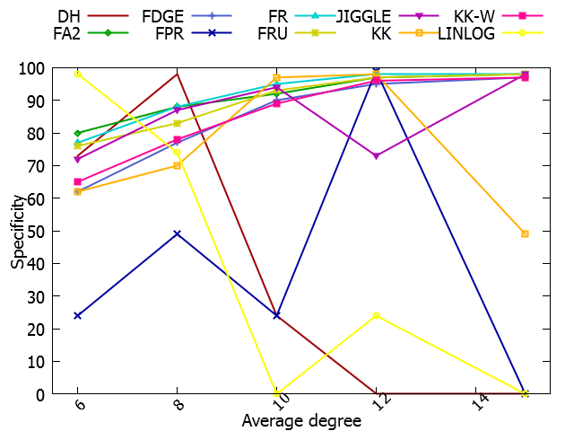

(a)

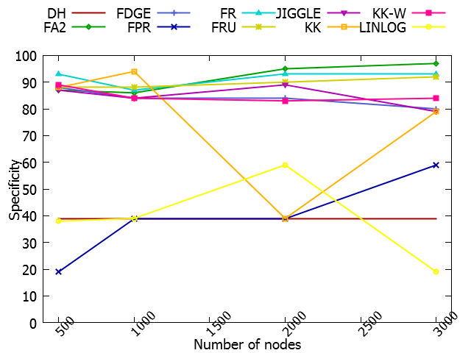

(b)

***Figure 34 Specificity of hole detection of force-directed algorithms and (a) number of nodes and (b) average degree in sparse sensor network.***

Figure 34 (a) illustrated the specificity of hole detection in terms of variant number of force-directed algorithms and average degree. The experimental result of hole detection was plotted against the force-directed algorithms and with average degree 6, 8, 10 and 12 and 15 in sparse sensor network. Figure 34 (b) illustrated the specificity of hole detection in terms of variant number of force-directed algorithms and number of nodes. The experimental result of hole detection was plotted against the force-directed algorithms and with number of nodes 500, 1000, 2000 and 3000 in sparse sensor network.

The experimental results revealed that LinLog, FRR, and DH algorithms are zigzag regardless of the number of nodes in sparse sensor networks. Other force-directed algorithms such as KK-MS-DS, FDGE, FA2, FRU, KK, JIGGLE and FR algorithms achieve high specificity especially when the number of average degree is high. They achieve the highest specificity when the average degree is 10. However, the specificity of KK algorithm decreased when the number of nodes increased.

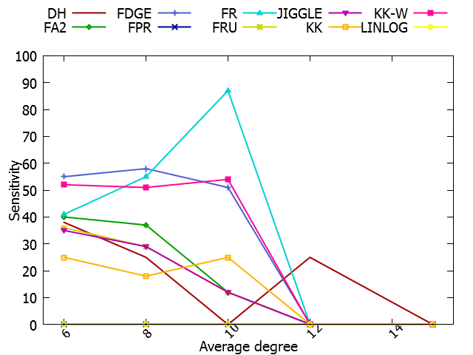

(a)

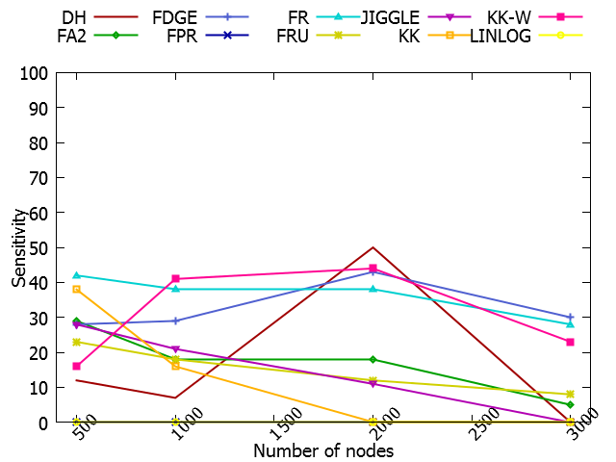

(b)

***Figure 35 Sensitivity of hole detection of force-directed algorithms and (a) number of nodes and (b) average degree in uniform sensor network.***

Figure 35 (a) illustrated the sensitivity of hole detection in terms of variant number of force-directed algorithms and average degree. The experimental result of hole detection was plotted against the force-directed algorithms and with average degree 6, 8, 10 and 12 and 15 in sparse sensor network. Figure 35 (b) illustrated the sensitivity of hole detection in terms of variant number of force-directed algorithms and number of nodes. The experimental result of hole detection was plotted against the force-directed algorithms and with number of nodes 500, 1000, 2000 and 3000 in sparse sensor network.

The experimental results revealed that all force-directed algorithms cannot achieve high sensitivity when the average degree is high especially when the average degree is higher than 12. The sensitivity is already less than 10%. Moreover, all force-directed algorithms do not have significant result of sensitivity regardless of the number of nodes in uniform sensor networks.

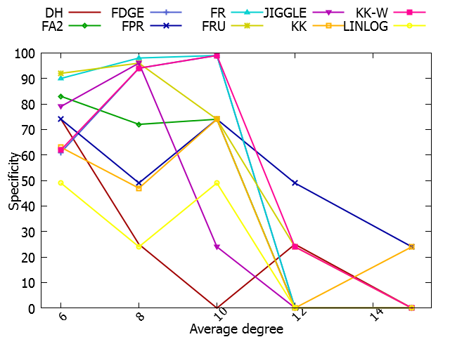

(a)

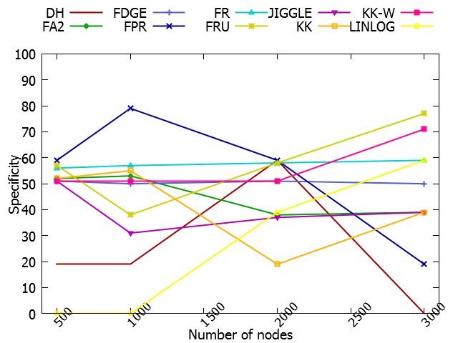

(b)

***Figure 36 Specificity of hole detection of force-directed algorithms and (a) number of nodes and (b) average degree in uniform sensor network.***

Figure 36 (a) illustrated the specificity of hole detection in terms of variant number of force-directed algorithms and average degree. The experimental result of hole detection was plotted against the force-directed algorithms and with average degree 6, 8, 10 and 12 and 15 in sparse sensor network. Figure 36 (b) illustrated the specificity of hole detection in terms of variant number of force-directed algorithms and number of nodes. The experimental result of hole detection was plotted against the force-directed algorithms and with number of nodes 500, 1000, 2000 and 3000 in sparse sensor network.

The experimental results revealed that result of specificity is similar to the result of sensitivity illustrated in Figure 35. All force-directed algorithms have a poor specificity when the average degree is larger than 12. Similar to the result of sensitivity, all force-directed algorithms do not have significant result of specificity regardless of the number of nodes in uniform sensor networks.

## Visualization of Hole Detection in Sensor Network by Convolutional Neural Network

After the performance evaluation, we used hole detection model to detected the hole in datasets of sensor networks. The detection also used Boundary Identification by Instance Segmentation which is proposed in Chapter 4.4 for reduce repeated result of detection and enhance visualization. The sample of visualization results are illustrated in Figure 37, Figure 38, Figure 39 and Figure 40 respectively. Those samples represented each number of nodes.

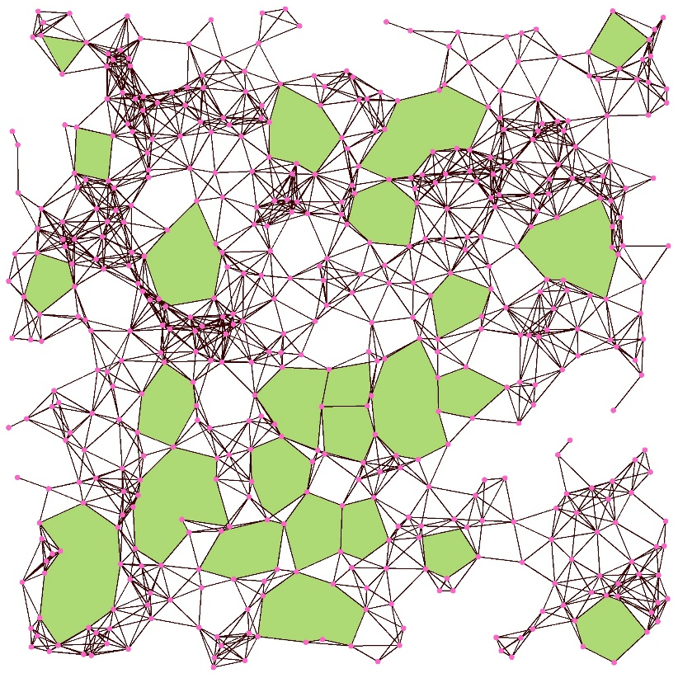

***Figure 37 The Sparse Sensor Networks with 500 nodes and 8 average degrees detected by Hole Detection Model.***

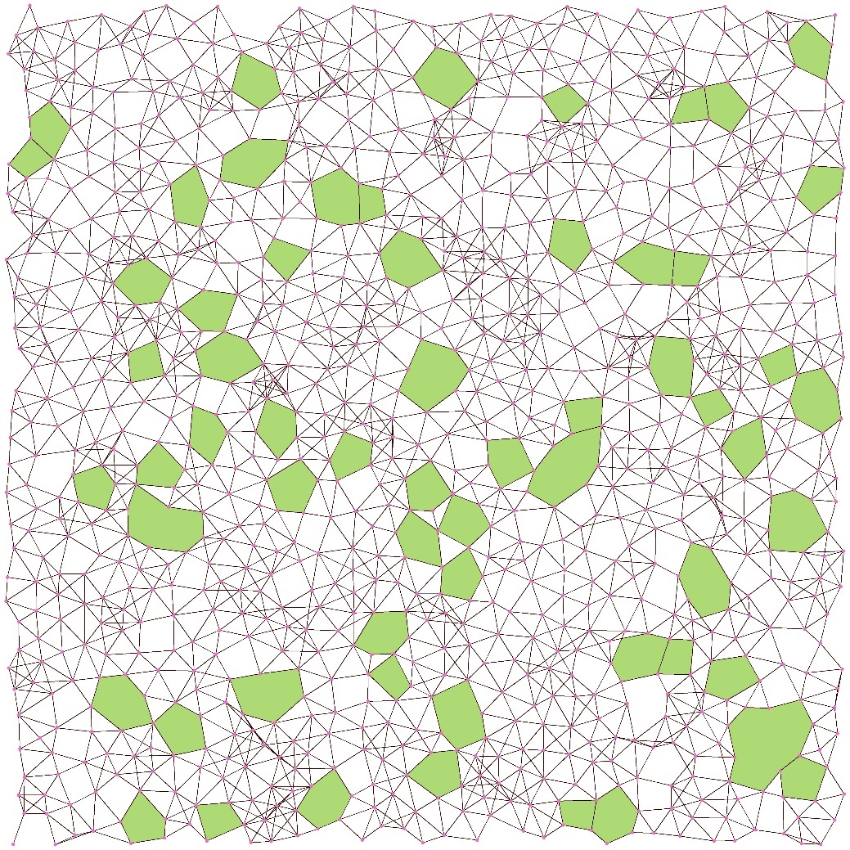

***Figure 38 The Uniform Sensor Networks with 1000 nodes and 6 average degrees detected by Hole Detection Model.***

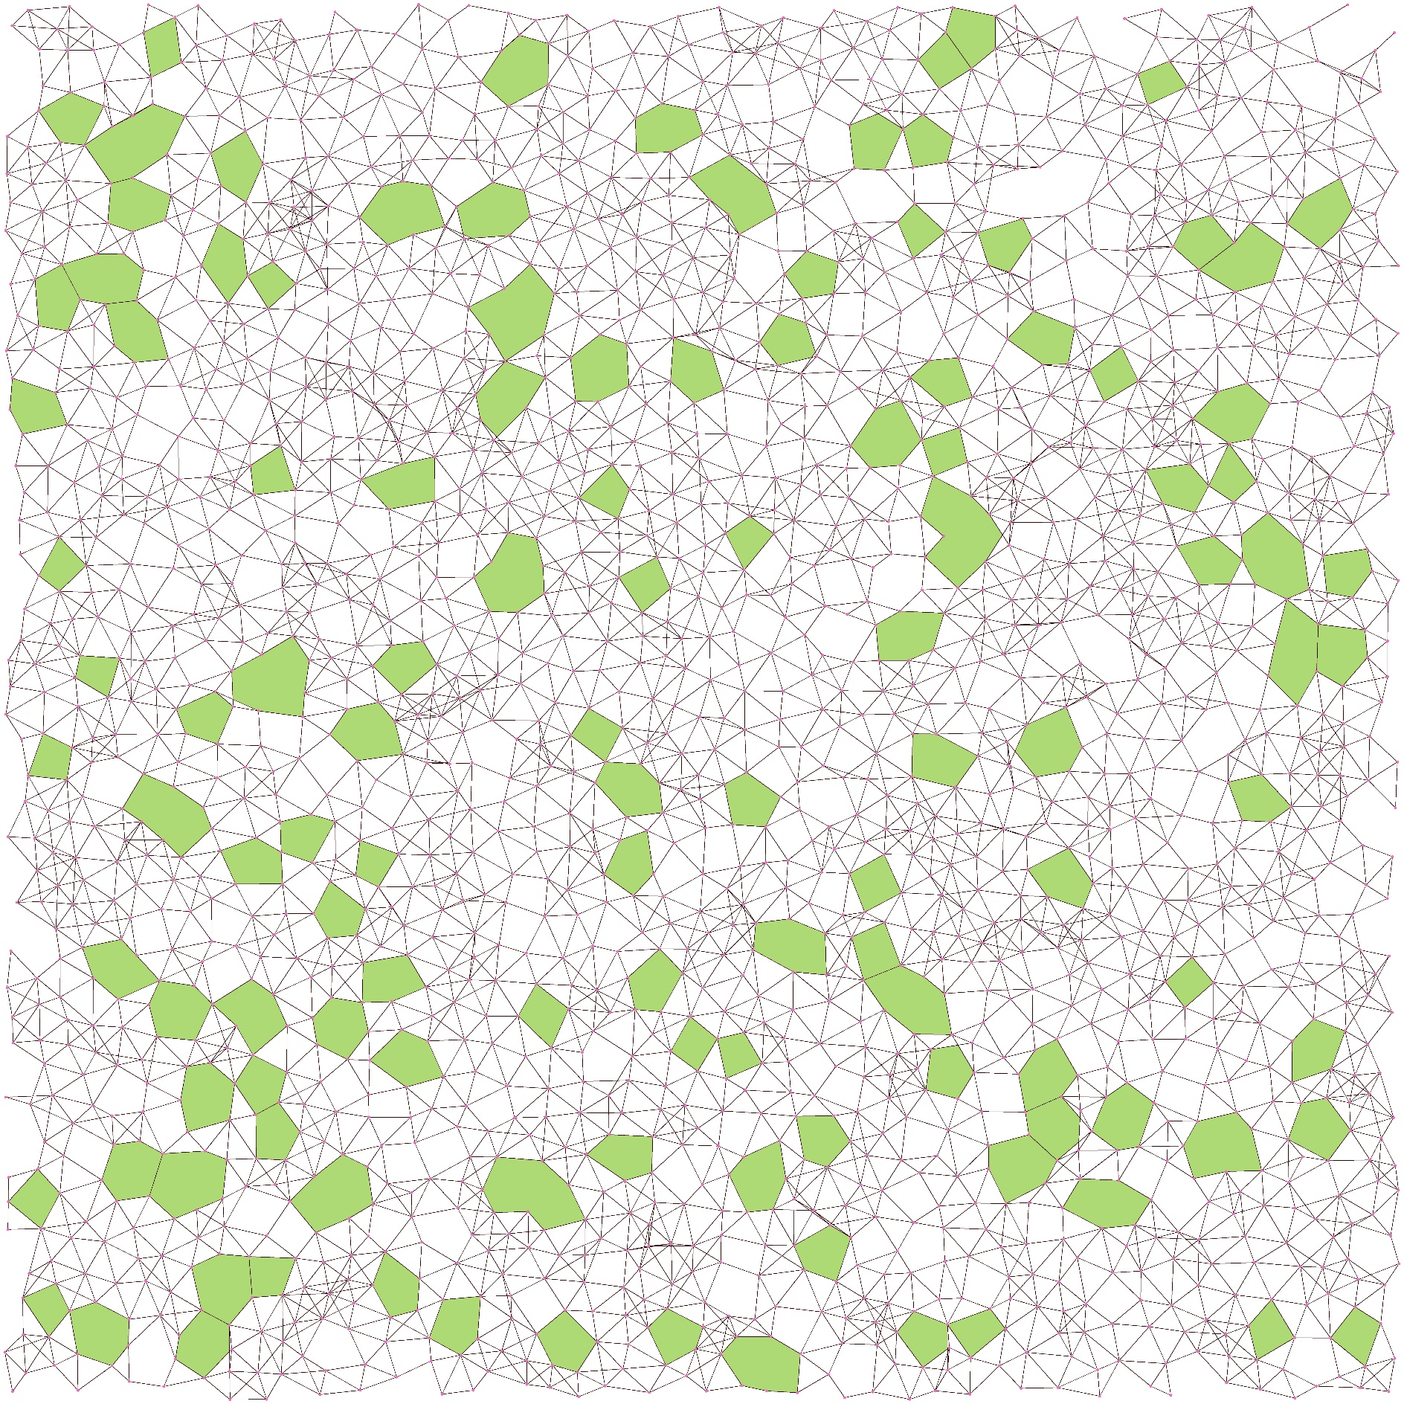

***Figure 39 The Uniform Sensor Networks with 2000 nodes and 6 average degrees detected by Hole Detection Model.***

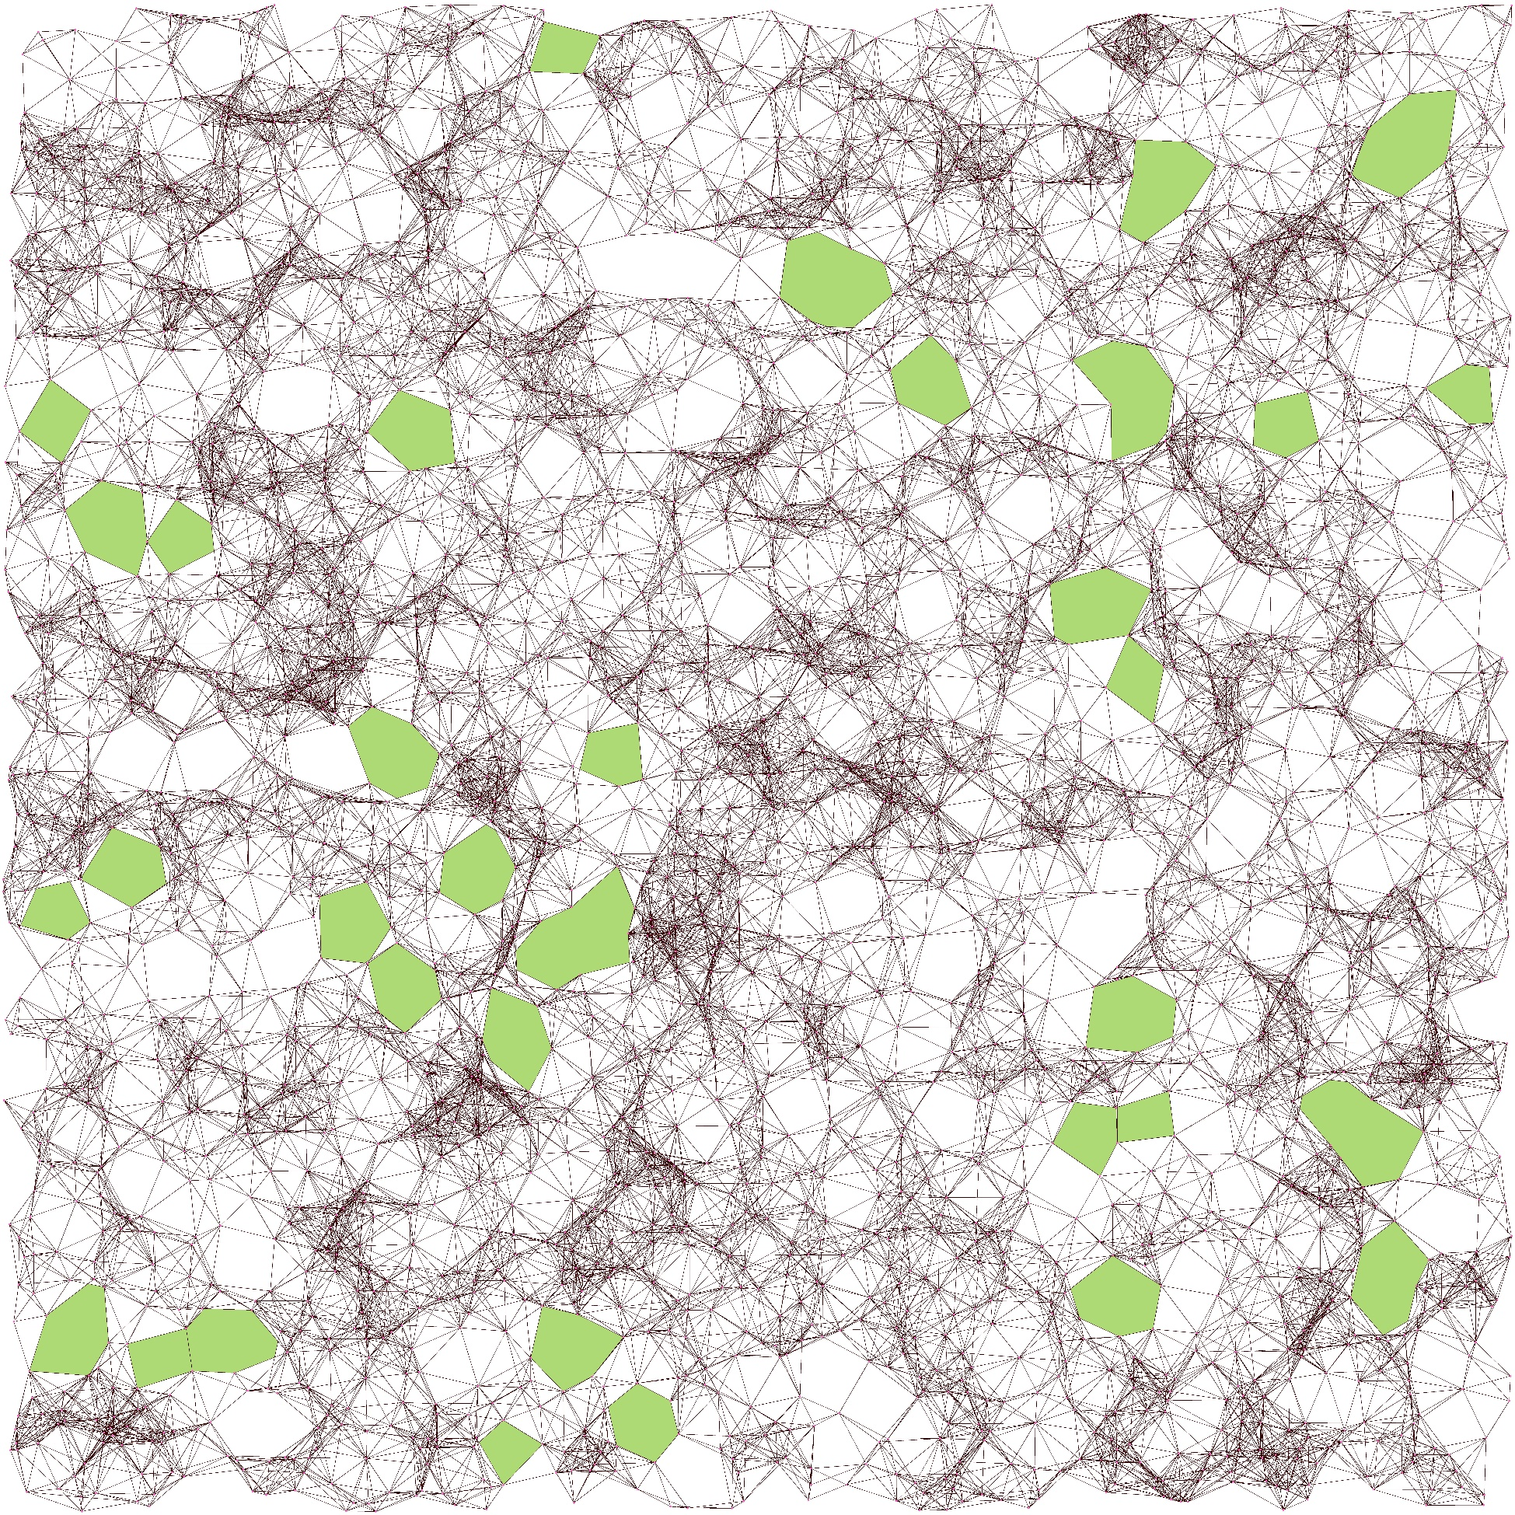

***Figure 40 The Sparse Sensor Networks with 3000 nodes and 15 average degrees detected by Hole Detection Model.***

Through the visualization of detected results by hole detection model, the model is able to detected hole object in sensor network. But we also discovered the model is not able to perfectly detect all hole in a sensor network. The detection missing is obvious in high average degrees sensor networks and uniform sensor networks. Their common structure is that the connection lines in the sensor network are too complicated. Therefore, the hole detection model is able to detect more hole object in low average degrees sensor network.

# ETHICS AND PROFESSIONAL CONDUCT

The initial of our project, we think about the users of the system will be the network engineer. Therefore, the input data of our system maybe the sensor network which is used in the company or a city. Because of our system will detected the hole in sensor network, and then the user may repair the hole in sensor network. The repaired hole induces hacker attack. There are privacy issues with data aspects. The input is a sensor network which may represent a network structure of an application or company, etc. The output is the holes and nodes of the holes of the input sensor network, this is a serious security issue if exposed. It is possible that hackers can attack the whole system from the hole. In a military application, the holes may to be used by the enemy and bury traps if the result sensor network exposed. Moreover, our system of Hole Detection does not retain user data, the most important is to ensure the user's data source and how to keep the results safely.

In code aspect, we used Python 3 and YOLOv3 [20] to build up Hole Detection in sensor network by CNN. YOLO was proposed by Joseph Redmon [9]. It is the open source system for people to use. YOLO contributed a great deal to our project. We have credited the hole detection system by CNN is based on YOLO Object Detection and used Python programming language implement the system. Those program code have thorough testing and debugging and ensure no errors in the system.

# CONCLUSION

The project has experimented Convolutional Neural Network (CNN) for hole detection in sensor networks. At the beginning, we have searched and tested pre-train models to predict the holes located on the sensor networks, and most of the prediction results are umbrella object. It represented sensor network are similar to umbrella in real life.

Afterwards, we have tried to train a model for Convolutional Neural Network (CNN) in order to detect the Irregular Shapes object in an image, because of the definition of the hole. Square shape is the simplest hole shape in sensor networks, so we used Square shape for training Irregular Shapes detection model. According to our experimental results, proposed model successfully predicted all the Irregular Shape from training images.

We proposed two approaches for collecting the feature of hole objects, they are Graph Segmentation and Feature Transformation. Graph Segmentation which is cut out a hole image from the resulted layout of force-directed algorithms. Feature Transformation is based on a hole the resulted layout of force-directed algorithms, then create a new hole object.

Each approach trained a model for detect holes in sensor networks. Two models are able to detected holes by using the resulted layout of force-directed algorithms. However, Graph Segmentation cannot detect some holes from the dataset of Feature Transformation. On the contrary, Feature Transformation can detect all the holes from the datasets of Graph Segmentation. It is proved that the approach Feature Transformation is a better approach to collect the feature of hole objects in sensor networks.

Moreover, we proposed Specific Classification which is based on Feature Transformation and steady information of hole object. Specific Classification is according the number of nodes located on the boundary of hole, and 4 object classes are classified. Therefore, the Convolutional Neural Network (CNN) model is used to detect holes in sensor network according to 4 object classes. However, the object classes of holes have insufficient training dataset problems. Some of the predictions are not clear and correct, it should increase the training dataset.

After above experimented, we assembled two approaches and Specific Classification to trained the final model of Convolutional Neural Network (CNN) hole detection. The model can apply for hole detection in a sensor network. It detected below 3000 nodes sensor network.

After the hole detection by Convolutional Neural Network (CNN) in sensor networks, the system designed two approaches to identify the boundary node on the hole. It is including, Boundary Identification and Node Identifier Recognition. Instant Segmentation is used Flood Fill Algorithm coloring each hole object in sensor networks. Node Identifier Recognition is separate layers and calculate the distance between hole and node. The approaches are effectively and correctly to identified the boundary nodes.

The difficult in Convolutional Neural Network (CNN) for hole detection which is to train a model. Due to a Convolutional Neural Network (CNN) model needs to spend 8 to 30 hours for model to train and learn hole object. The mistaken configuration, it influences the detection and preciseness for hole detection by Convolutional Neural Network (CNN). So before training a model, we need carefully to check training config, using correct training dataset, and stable environment for the training computer. The faulty model is extremely time-consuming.

Finally, we successfully designed Convolutional Neural Network (CNN) for hole detection in sensor networks. According to our experimental results, hole detection by Convolutional Neural Network (CNN) has not been able to detect more than 80% sensitivity in sparse sensor networks.

For our future works, force-directed algorithms cooperate with Convolutional Neural Network (CNN), it is able to generate sensor network and simultaneously detect hole. It can early and correctly to stop running force-directed algorithms, and also may able to tracking the formation of a hole from the generated sensor networks. Therefore, this approach may improve force-directed algorithms generate a more suitable sensor network.

This project has implemented hole detection in sensor networks by Object Detection with Convolutional Neural Network (CNN). Object Detection is one of Deep Learning Approach. In addition to Object Detection, we think Edge Detection also can be Deep learning Approach for hole detection in sensor network. Ankit Sachan [32] has proposed Deep Learning approach based on Edge Detection by using Canny Edge Detection Algorithm. The approach treats edge detection as a signal processing problem, so it strengthens to identify the boundary of object. Therefore, Edge Detection is able to improve the recognition of hole boundary, it can improve the limitation problem of the network size in Object Detection. Edge Detection also can reduce the time of training model. This project temporarily implemented the Edge Detection for hole detection in sensor network. After this project, we believe Edge Detection by Deep Learning approach it also achieves for hole detection in sensor networks.

# REFERENCE

[1] R. Tamassia, *Handbook of graph drawing and visualization*. Chapman and Hall/CRC, 2013.

[2] P. K. Sahoo, J.-P. Sheu, and K.-Y. Hsieh, "Target tracking and boundary node selection algorithms of wireless sensor networks for internet services," *Information Sciences,* vol. 230, pp. 21-38, 2013.

[3] G. Destino and G. T. F. de Abreu, "Network boundary recognition via graph-theory," in *2008 5th Workshop on Positioning, Navigation and Communication*, 2008, pp. 271-275: IEEE.

[4] S. Funke, "Topological hole detection in wireless sensor networks and its applications," in *Proceedings of the 2005 joint workshop on Foundations of mobile computing*, 2005, pp. 44-53.

[5] K.-Y. Hsieh and J.-P. Sheu, "Hole detection and boundary recognition in wireless sensor networks," in *2009 IEEE 20th International Symposium on Personal, Indoor and Mobile Radio Communications*, 2009, pp. 72-76: IEEE.

[6] Y. Wang, J. Gao, and J. S. Mitchell, "Boundary recognition in sensor networks by topological methods," in *Proceedings of the 12th annual international conference on Mobile computing and networking*, 2006, pp. 122-133.

[7] A. Dabba and R. Beghdad, "BCP: A Border Coverage Protocol for wireless sensor networks," in *2014 Science and Information Conference*, 2014, pp. 632-640: IEEE.

[8] I. M. Khan, M. Z. Khan, H. Mokhtar, and M. Merabti, "Enhancements of the self-detection scheme for boundary recognition in wireless sensor networks," in *2011 Developments in E-systems Engineering*, 2011, pp. 448-453: IEEE.

[9] T. M. Fruchterman and E. M. Reingold, "Graph drawing by force‐directed placement," *Software: Practice and experience,* vol. 21, no. 11, pp. 1129-1164, 1991.

[10] T. Kamada and S. Kawai, "An algorithm for drawing general undirected graphs," *Information processing letters,* vol. 31, no. 1, pp. 7-15, 1989.

[11] R. Davidson and D. Harel, "Drawing graphs nicely using simulated annealing," *ACM Transactions on Graphics (TOG),* vol. 15, no. 4, pp. 301-331, 1996.

[12] M. Jacomy, T. Venturini, S. Heymann, and M. Bastian, "ForceAtlas2, a continuous graph layout algorithm for handy network visualization designed for the Gephi software," *PloS one,* vol. 9, no. 6, 2014.

[13] D. Holten and J. J. Van Wijk, "Force‐directed edge bundling for graph visualization," in *Computer graphics forum*, 2009, vol. 28, no. 3, pp. 983-990: Wiley Online Library.

[14] A. Efrat, D. Forrester, A. Iyer, S. G. Kobourov, C. Erten, and O. Kilic, "Force-directed approaches to sensor localization," *ACM Transactions on Sensor Networks (TOSN),* vol. 7, no. 3, pp. 1-25, 2010.

[15] S.-H. Cheong and Y.-W. Si, "CWBound: boundary node detection algorithm for complex non-convex mobile ad hoc networks," *The Journal of Supercomputing,* vol. 74, no. 10, pp. 5558-5577, 2018.

[16] D. Tunkelang, "JIGGLE: Java interactive graph layout environment," in *International Symposium on Graph Drawing*, 1998, pp. 413-422: Springer.

[17] A. Noack, "Energy Models for Graph Clustering," *J. Graph Algorithms Appl.,* vol. 11, no. 2, pp. 453-480, 2007.

[18] S.-H. Cheong and Y.-W. Si, "Accelerating the Kamada-Kawai algorithm for boundary detection in a mobile ad hoc network," *ACM Transactions on Sensor Networks (TOSN),* vol. 13, no. 1, pp. 1-29, 2016.

[19] K. Fukushima, "Neocognitron: A self-organizing neural network model for a mechanism of pattern recognition unaffected by shift in position," *Biological cybernetics,* vol. 36, no. 4, pp. 193-202, 1980.

[20] J. Redmon and A. Farhadi, "Yolov3: An incremental improvement," *arXiv preprint arXiv:1804.02767,* 2018.

[21] AlexeyAB. (2019, March 9, 2020). *Yolo-v3 and Yolo-v2 for Windows and Linux*. Available: <https://github.com/lkkuu88/yolo-v3>

[22] K.-Y. Wong. (2019, March 9, 2020). *Cross Stage Partial Networks*. Available: <https://github.com/WongKinYiu/CrossStagePartialNetworks/>

[23] C.-Y. Wang, H.-Y. M. Liao, I.-H. Yeh, Y.-H. Wu, P.-Y. Chen, and J.-W. Hsieh, "CSPNet: A New Backbone that can Enhance Learning Capability of CNN," *arXiv preprint arXiv:1911.11929,* 2019.

[24] C.-Y. Wang, H.-Y. Mark Liao, P.-Y. Chen, and J.-W. Hsieh, "Enriching Variety of Layer-wise Learning Information by Gradient Combination," in *Proceedings of the IEEE International Conference on Computer Vision Workshops*, 2019, pp. 0-0.

[25] M. Tan and Q. V. Le, "Efficientnet: Rethinking model scaling for convolutional neural networks," *arXiv preprint arXiv:1905.11946,* 2019.

[26] T.-Y. Lin *et al.*, "Microsoft coco: Common objects in context," in *European conference on computer vision*, 2014, pp. 740-755: Springer.

[27] A. Kuznetsova *et al.*, "The open images dataset v4: Unified image classification, object detection, and visual relationship detection at scale," *arXiv preprint arXiv:1811.00982,* 2018.

[28] J. Redmon and A. Farhadi, "YOLO9000: better, faster, stronger," in *Proceedings of the IEEE conference on computer vision and pattern recognition*, 2017, pp. 7263-7271.

[29] tzutalin. (2018, March 15, 2020). *labelImg*. Available: <https://github.com/tzutalin/labelImg>

[30] J. Matousek, *Lectures on discrete geometry*. Springer Science & Business Media, 2013.

[31] S.-H. Cheong. (2017, March 2, 2020). *CNCAHNetGenerator - CNCAH Network Generator*. Available: <http://eric.lostcity-studio.com/system-design/cncahnetgenerator-cncah-network-generator/>

[32] A. Sachan. (2020, May 25, 2020). *Deep Learning based Edge Detection in OpenCV*. Available: <https://cv-tricks.com/opencv-dnn/edge-detection-hed/>

1. <https://github.com/pjreddie/darknet/blob/master/cfg/yolov3.cfg>
2. <https://github.com/pjreddie/darknet/blob/master/cfg/yolov3-tiny.cfg>